|  |
| --- |
| 2022 |
| I.P.T MEXICO PANAMA    Profesor:  Lilybeth Gonzalez   * 6522-7626 |

MÓDULO DE INGLÉS

III TRIMESTRE

NIVEL:

8° D,E,F.

ESTUDIANTE

_________________________________________________

FECHA DE ENTREGA

21 de noviembre al 2 de diciembre, 2022



* **Indicaciones Generales:**

1. Desarrollar las actividades de la guía, con ayuda del contenido en ella.

2. La guía, debe entregarlo engrapado solamente. Evite el uso de folder o cartapacio. Siga ésta indicación, forma parte de su evaluación.

3.. añadir vocabulario en cada actividad, de acuerdo a las palabras que desconoce, colocar su significado en español.

* **Evaluación:**

⎫ El desarrollo de cada tema equivale a una nota diaria y una de apreciación.

⎫ En cada tema desarrollado se le evaluará lo siguiente:

* Que haya desarrollado cada taller correspondiente a cada tema en la guía de trabajo. Puede agregar páginas adicionales si es necesario o utilizar hojas de rayas o blancas para desarrollar mejor las actividades.
* Todas las respuestas deben estar escrita con bolígrafo azul o negro. Puede usar resaltadores, lápices de colores si es necesario para resaltar. Valor 5 pts.
* Orden, aseo, ortografía y nitidez del trabajo. Valor 5 pts
* Respuestas correctas. Valor____pts. Dependerá de la cantidad de pregunta que tiene cada sección de acuerdo al módulo.
* Seguir todas las indicaciones que ha dado el profesor para el desarrollo de los módulos. Valor 5 pts

Nota Importante: No se evaluará la puntualidad; ya que, no queremos perjudicar aquellos estudiantes que por algún motivo no le llegó el módulo a tiempo. Trate en lo posible de ir desarrollando todos los ejercicios en el menor tiempo.

**TOPIC # 1 – ACTION VERBS**

**Action verbs are verbs that are used to describe a specific job or activity.**

**Translate 20 action verb and illustrate 10. 30pts**

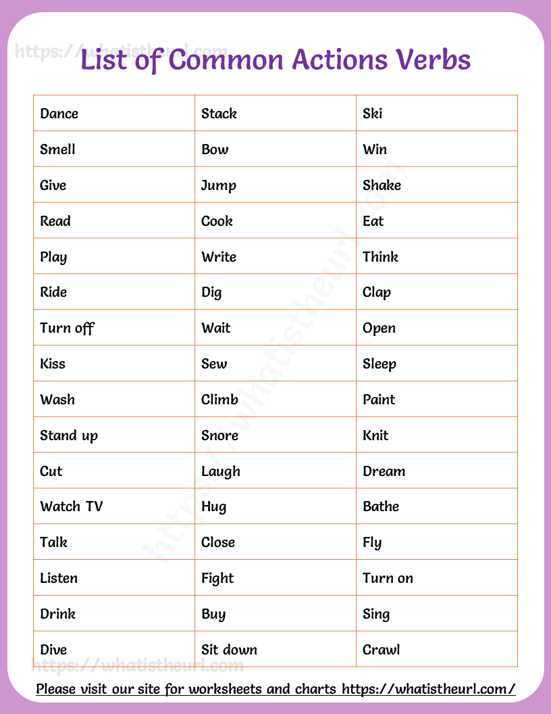





We use the **Present Simple**:

* for **habits** and actions that we do regularly:

He visits his friends every Sunday.

She goes to school by bus.

* for **general truths**:

The sun rises in the East.

* for **permanent situations**: He lives in Athens.



**Third person singular**

We add –s to the verb to form the third person singular (**he, she, it**).

I drink – he drinks I run – he runs

**BUT**

* We add –es to verbs that end in **–ss**,

**-sh**, **-ch**, **-x**, **-o**.

I watch – he watches

* With verbs ending in **consonant + y**, we change the –y to –ies.

I cry – he cries

**But** with verbs ending in **vowel + y**, we just add –s as usual.

I play – he plays



**Short answers Affirmative**

Yes, I / you / we / they **do**

Yes, he / she / it **does**

**Negative**

No, I / you / we / they **don’t**

No, he / she / it **doesn’t**



**Interrogative Do** I walk?

**Do** you walk? **Does** he walk? **Does** she walk? **Does** it walk?

**Do** we walk? **Do** you walk? **Do** they walk?



**Negative**

I **don’t** walk You **don’t** walk He **doesn’t** walk

She **doesn’t** walk It **doesn’t** walk We **don’t** walk You **don’t** walk They **don’t** walk



**Afirmative**

I walk You walk He walk**s** She walk**s** It walk**s** We walk You walk They walk

**TOPIC # 2 – SIMPLE PRESENT**



**Expressions** used with the Present Simple

**Frequency adverbs:** always, usually, often, sometimes, rarely, never

(they are placed before the main verb)

**Time expressions:** every day / week / Friday…

on Mondays / Sundays… at the weekend…

in the morning / afternoon… in winter / spring…

once a day / week…

PRACTICE #1 SIMPLE PRESENT

50pts

1. Write the third person singular of the following verbs.



|  |  |  |  |
| --- | --- | --- | --- |
| play |  | go |  |
| wash |  | teach |  |
| drive |  | carry |  |
| fly |  | start |  |
| help |  | kiss |  |
| watch |  | tidy |  |
| like |  | enjoy |  |
| cry |  | mix |  |

1. Complete the sentences with the Present Simple of the verbs in brackets.
   1. Peter and his friends to school by bus. (go)
   2. Elephants leaves and grass. (eat)
   3. David's father in a hospital. (work)
   4. The bank opens at 9.30 and at 4.30. (close)
   5. Tom and Jim
   6. Mr. Jones is a teacher.

football every day after school. (play)

History. (teach)

* 1. Our lessons at 9.00 and at 3.30. (start / finish)
  2. My pen friend in Japan. (live)
  3. Mary and her brother cartoons every Sunday morning. (watch)
  4. John his room every day. (tidy)

1. Complete the blanks with the Present Simple of the verbs in the box.

go ~~work~~ ride deliver love jog rest fish walk



Mr. Letty is a postman. He doesn't work in the post office. He always ***works*** outside in the streets.

He letters to all the people in the neighborhood every day. He doesn’t but he his motorbike.

At the weekend, Mr. Letty doesn't work.

He . He the countryside, so he always to his country house with his wife. Mr and Mrs Letty in the river and they in the woods every weekend.

1. Look at the pictures and write questions and answers, as in the example.
   1. play / the guitar / in the afternoon

***Does he play the guitar in the afternoon?***

***No he doesn’t play the guitar in the afternoon. He plays the accordion.***

* 1. walk / after lunch.
  2. ride / their / bicycles / to work / every day. listen / to the radio / every Sunday
  3. clean / the house / on Mondays
  4. watch / TV / after school

**WORKSHEET #1 SIMPLE PRESENT 36pts**

I part; Choose the correct verb from the list below to complete the following sentences. Use the correct form of the simple present tense. 14pts

**fix, speak, drink, eat, do, wear, have, wash, make, listen, buy, take, watch brush**

1. I ___________ breakfast at 7:00 every morning.

2. He always ____________ a suit to work.

3. The teacher ____________ at the front of the classroom.

4. He ________________ his teeth three times a day.

5. We usually ______________ our groceries on the weekend.

6. He _____________ a meeting every morning.

7. She often ______________ chicken for dinner.

8. They _____________ the bus to school every day.

9. We often ____________ television in the evenings.

10. He _____________ to the radio on his way to work.

11. The teacher ______________ three languages.

12. A mechanic _______________ cars.

13. She ___________ the dishes after dinner.

14. They _____________ coffee every morning

II part; Make negative sentences using the correct verbs from the list below. 14pts

**Speak, know, go, need, want, drink, love, be, move, smoke, wear, sell, have, get up, serve**

Ex. 1. She is Japanese. She doesn’t speak French.

1. I ______________ any dinner because I am not hungry.

2. Jerry and Beth are strangers. They _________________ each other.

3. We ________________ to school on the weekend.

4. Mrs. Smith wants a divorce. She ______________ her husband anymore.

5. Turtles ___________________ quickly.

6. Children _________________ coffee.

7. You _______________ jeans to a wedding.

8. Poor people ________________ a lot of money.

9. It’s warm today. You ________________ to wear a coat.

10. Jessica is very healthy. She __________________cigarettes.

11. The students are from China. They_________________ English.

12. The shoe store _____________ hats.

13. That restaurant ________________ breakfast.

14. The children ______________ early on the weekend.

IV part. Yes/No Questions Practice making questions and giving short answers in the simple present tense. Ex. Do you wake up early every day? Yes, I do. (I wake up early every day.)

1. (He takes the bus to school.)

2. (They don’t live in a big city.)

3. (We like to play tennis.)

4. (They don’t watch TV a lot.)

5. (He lives in an apartment.)

6. (The students work hard.)

7. She doesn’t eat in the cafeteria.)

8. (I speak French.)

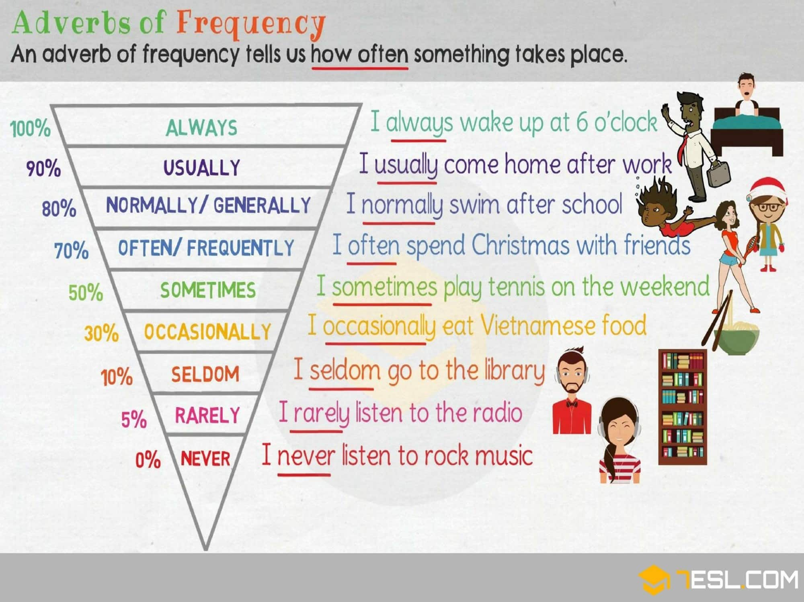

**TOPIC # 3 – Adverbs of frequency**

**Practice #2 Simple Present Tense and Frequency Adverbs** 10pts

I part A. Choose the correct verb from the list below to complete the following sentences. Use the correct form of the simple present tense. eat / travel / play / listen to / help / shop / drink / rain / take / do

1. I never __________________________ coffee before I go to bed.

2. She always __________________________ her mother with the housework.

3. Her husband never __________________________ the laundry.

4. They usually __________________________ the bus to school.

5. We seldom __________________________ dinner in a restaurant.

6. They rarely __________________________ to different countries.

7. She usually __________________________ at the supermarket near her home.

8. We sometimes __________________________ cards on the weekend.

9. It often __________________________ in April.

10. Teenagers seldom __________________________ their parents.

**WORKSHEET #2 Adverbs of frequency 17pts**

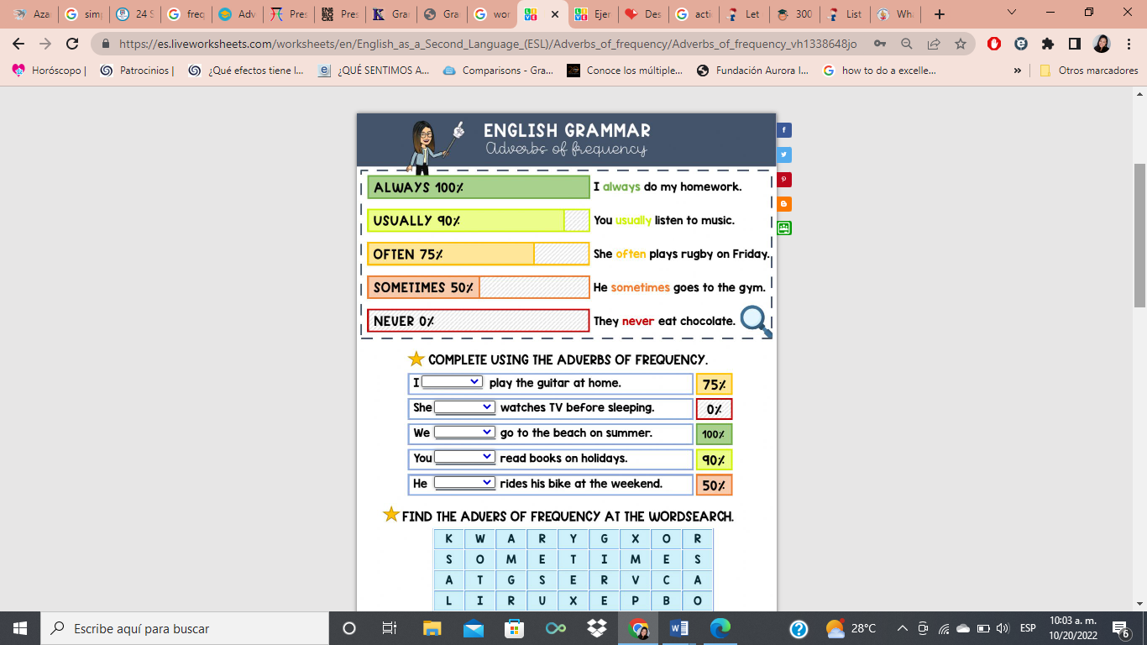



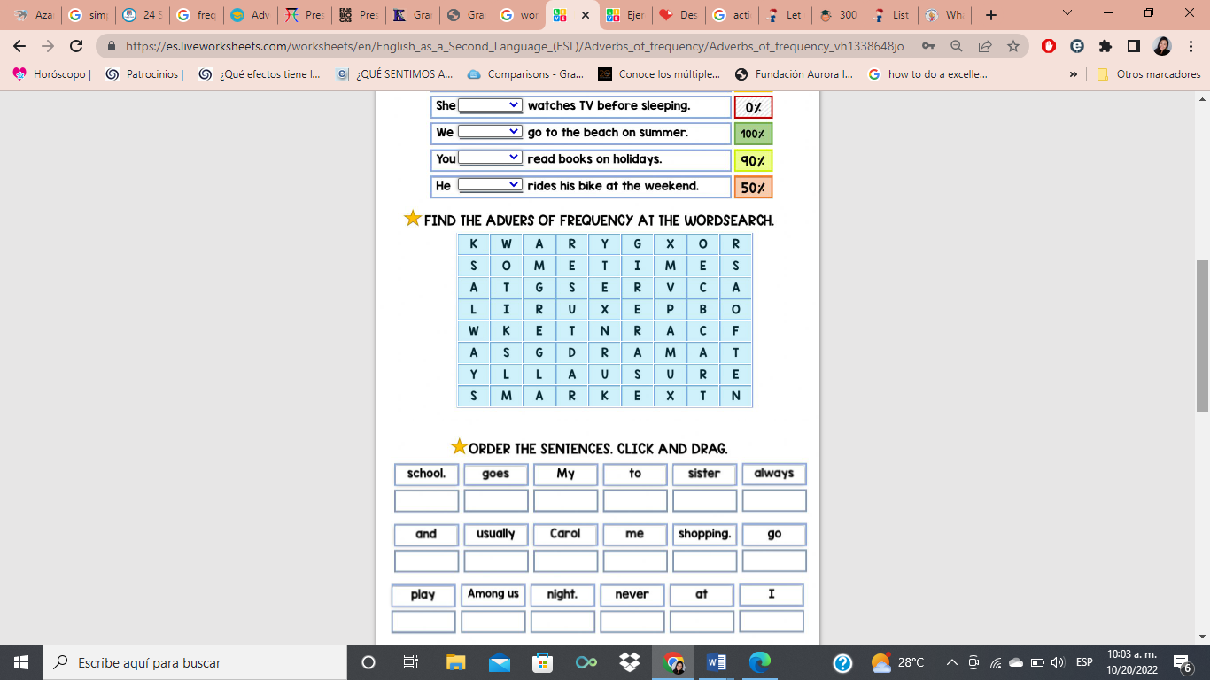

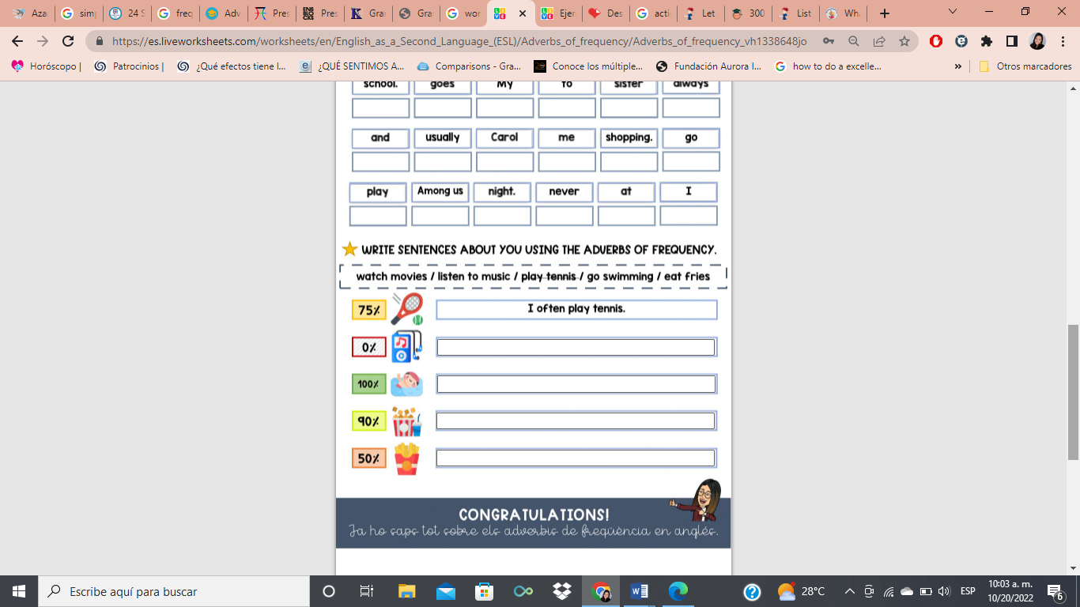

**Worksheet 3. Verbs: Everyday activities 11pts**

**Complete the sentences. Choose a verb from each word pool. Write the correct form of the verb in the blank space.**

**go work take**

1. I _______ in an office every day during the week.

2. I _______ a walk in the park every day.

3. I _______ to the beach every weekend.

**eat drink live speak**

4. My friend Carlo _______ in Italy.

5. He _______ Italian every day.

6. He _______ Italian food, and he _______ Italian coffee.

**climb eat drink sleep**

 [](http://www.clipart.com/en/close-up?o=3760584&a=a&q=%22cat%22%20and%20%22tree%22&k_mode=all&s=109&e=126&show=&c=&cid=&findincat=&g=&cc=103:2:25:0:2:90:0&page=7&k_exc=&pubid=&color=&b=k&date=)

**bear cat**

7. Bears _______ during the winter.

8. Big fish _______ little fish.

9. Cats _______ milk.

10. Cats _______ trees.

|  |  |  |  |  |  |
| --- | --- | --- | --- | --- | --- |
|  | **Puntualidad**  **5pts** | **Orden, aseo, nitidez 5pts** | **Practice**  **pts** | **Worksheet**  **pts** | **Total pts** |
| **Excelente** |  |  |  |  |  |
| **Bueno** |  |  |  |  |  |
| **Por mejorar** |  |  |  |  |  |
| **No satisface** |  |  |  |  |  |

|  |  |  |  |  |  |
| --- | --- | --- | --- | --- | --- |
|  | **Puntualidad**  **5pts** | **Orden, aseo, nitidez 5pts** | **Practice**  **pts** | **Worksheet**  **pts** | **Total pts** |
| **Excelente** |  |  |  |  |  |
| **Bueno** |  |  |  |  |  |
| **Por mejorar** |  |  |  |  |  |
| **No satisface** |  |  |  |  |  |

|  |  |  |  |  |  |
| --- | --- | --- | --- | --- | --- |
|  | **Puntualidad**  **5pts** | **Orden, aseo, nitidez 5pts** | **Practice**  **pts** | **Worksheet**  **pts** | **Total pts** |
| **Excelente** |  |  |  |  |  |
| **Bueno** |  |  |  |  |  |
| **Por mejorar** |  |  |  |  |  |
| **No satisface** |  |  |  |  |  |