MEDUCA
IPT MÉXICO-PANAMÁ
GUIDES OF WORKSHOP FOR THE REST OF THE SECOND TRIMESTER
GUÍA DE INGLÉSDEL TERCER TRIMESTRE 2022
12ª GRADES SCIENCE E, F G AND H
TEACHER: JOSÉ VILAS
CONTACTO: CELLPHONE: 66457856
CORREO ELECTRÓNICO : josevilas189@gmail.com
FECHAS DE ENTREGA:

WORKSHOP 1 PRIMER DÍA QUE NOS VEAMOS EN EL SALÓN DE CLASES.
WORKSHOP 2 Y 3 | El día 8 de noviembre los grupos 12 E y F
WORKSHOP 2 y 3 | El día 9 de noviembre los grupos 12 G y H
WORKSHOPS 4, 5 y 6 | El día 22 de noviembre los grupos 12 E y F
WORKSHOPS 4, 5 y 6 | El día 23 de noviembre los grupos 12 G y H
ENTREGA DE TRABAJOS PENDIENTES (Favor presentar excusa de su acudiente que justifique la entrega tardía.) | Los días 25, 29 y 30 de noviembre.

TOPICS
Review of the going to
Connecting ideas with
besides, moreover, etc.
- Connecting ideas
with so and because
-Why and because
Cultural diversity and
international tourism.
- Travel
- Hotel reservation
- Airports
- Money exchange
- Restaurants
- Means of
transportation
- Tourist sites
The English language
around the world.
- Importance
- Science
- Communication
- Other areas
- English speaking
countries
-Location
-History

TOPICS NUMBER 1

REVIEW OF “GOING TO” IN A SMALL COMPOSITION

Going to»
El tiempo futuro con «going to» se usa más comúnmente en el lenguaje hablado cuando se quiere hacer referencia al futuro inmediato, es decir, a algo que está por ocurrir.
Ejemplos:
- She is going to pay with a credit card = Ella va a pagar con una tarjeta de crédito (algo que está por ocurrir).
- I am going to drop off my prescription over there = voy a dejar mi prescripción médica allá.
También se emplea para hablar de intenciones o planes para hacer algo:
Ejemplo:
- I’m going to learn English = voy a aprender inglés.

Se forma con el verbo«to be» conjugado para la persona correspondiente, seguido de«going to» y el verbo base:

«To be» + «going to» + verbo:
- I am going to pay = Yo voy a pagar.
- You are going to pay = Tú vas a pagar.
- He is going to pay = Él va a pagar.
- She is going to pay = Ella va a pagar.
- It is going to pay = Eso va a pagar.
- We are going to pay = Nosotros vamos a pagar.
- You are going to pay = Ustedes van a pagar.
- They are going to pay = ellos/ellas van a pagar.

Connectors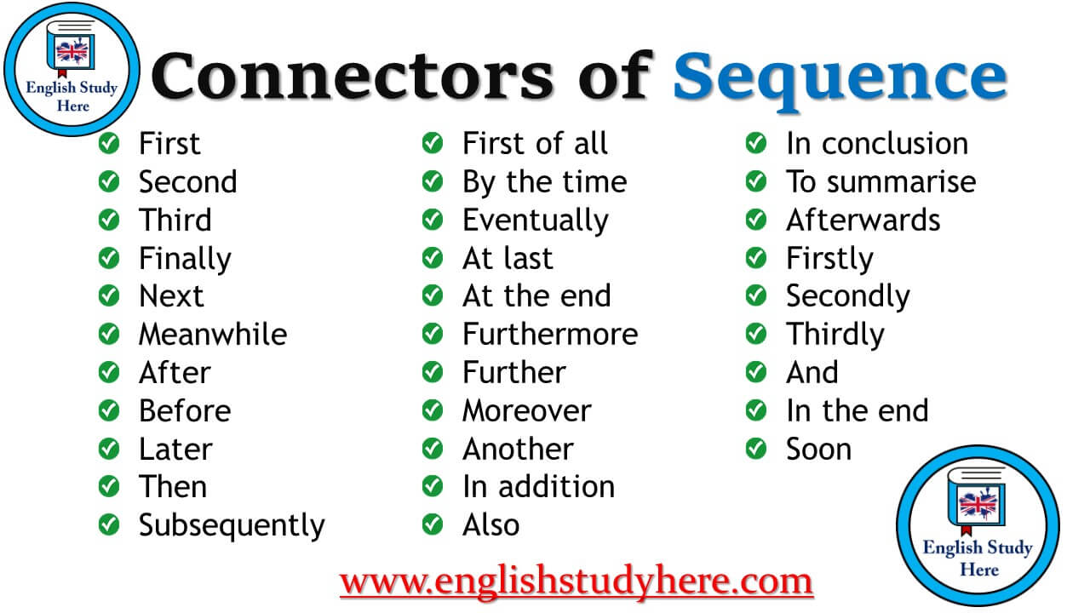

Then = después First of all = primero que nada Besides= además ´

Morover = también Afterwards = posteriormente Furthermore= además Later = luego

In addition= Adicional a ello
Subsequently = subsecuentemente
And = y

WORKSHOP nº1

Write a composition about your dream vacation.
( 40 points)
You should include the following:
TEN (10) sentences using the going to ( 3 points each)
For example: I am going to go to Australia
Nine (9) connectors between each sentence ( I point each)
For example: I am going to go to Australia, and I am going to see koalas at the zoo there.

Remember to use the correct spelling. And remember that the first word of a sentence is always capitalized.

Debes incluir lo siguiente :
10 oraciones usando el “going to “ sobre tus vacaciones soñadas.
9 conectores para unir las oraciones
Recuerda que se descontará puntos por faltas ortográficas y gramaticales y que la primera palabra de la oración se escribe con mayúscula. Se descotará un punto de los 40 por cada error de spelling o grammar.

OBSERVACIÓN: Este workshop se hará después de escuchar las recomendaciones del teacher.

TOPIC NUMBER 2
SO AND BECAUSE
SO = ASÍ ES QUE, POR CONSIGUIENTE
BECAUSE = PORQUE

What’s The Difference Between “So” And “Because”?

USE BECAUSE TO EXPRESS A REASON:
He is the best student because he studies a lot.
(result) <———- (reason)
- I didn’t go to class because I was sick.
- We arrived early today because we have a meeting at 7:00 AM.
- She got presents because it was her birthday.

USE SO TO EXPRESS A RESULT:
He studies a lot, so he is the best student.
(reason) ——–> (result)
- Jane didn’t like the movie, so she turned off the TV.
- Yesterday was a holiday, so the school was closed.
- I lost my car keys, so I took a taxi.

So suele traducirse como «así que», e introduce una oración subordinada consecutiva: esta oración nos dirá la consecuencia de la oración anterior. A su vez, because suele traducirse como «porque», e introduce una oración subordinada causativa, esta oración expresa la causa por la que la principal puede o no ocurrir.
Como se puede observar, las oraciones de so y because son antagónicas: podemos reescribir una dándole la vuelta y usando la conjunción opuesta, y seguiremos teniendo la misma información.
Observemos unos ejemplos (para nada proféticos, en serio) del uso de estos conectores:
He didn’t study for the exam, so he failed (No estudió para el examen, así que fracasó).

He failed because he didn’t study for the exam (Fracasó porque no estudió para el examen).

After this explanation work on the workshop Nº2
40 points ---3 points each answer
For example:
9- We stay at home because, it was raining.
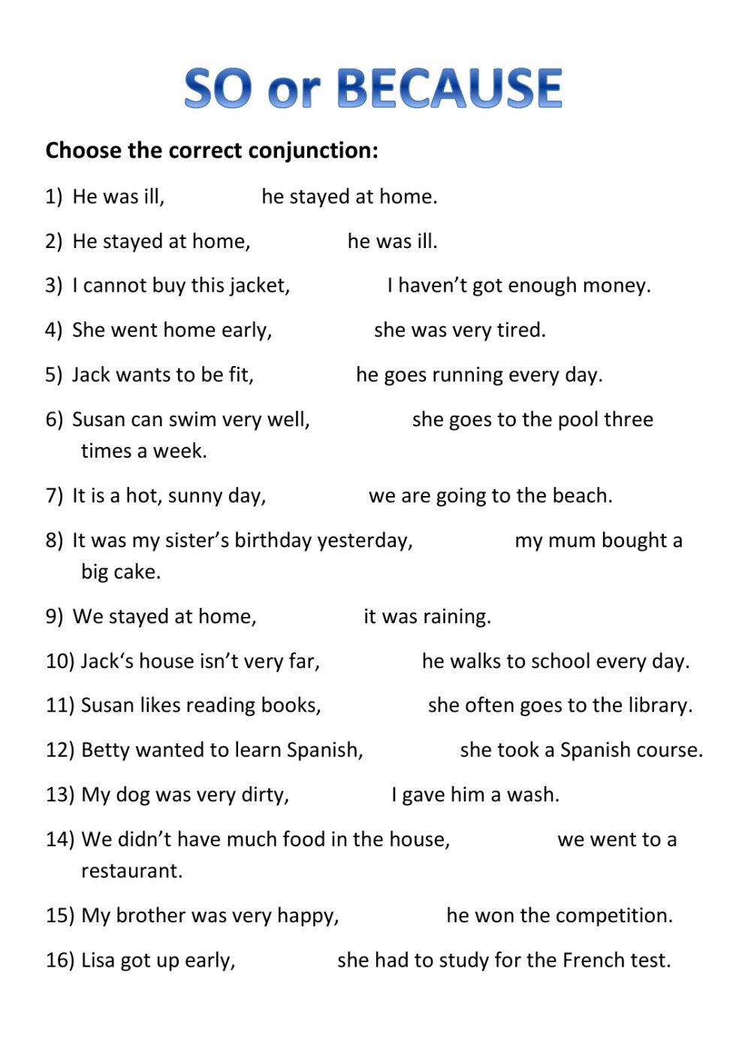
WOKSHOP NUMBER 2
NAME : _________________________________
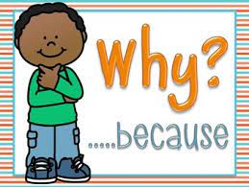

TOPIC NUMBER 3
WHY ? BECAUSE……

Information Questions with "Why" Question Word with am - is - are
"Why" question asks for information about reason, explanation:
Form: Why + am/is/are + Subject + (adjective or preposition)
Singular Subject: Why is the man late?
Plural Subject: Why are they late?
Why are you here?  Why is she late?  Why are they at home?  Why isn't Tom at work?  Why are your sisters angry? | Why isn't she at school?  Why aren't there any eggs?  Why is the window open?  Why are your shoes dirty?  Why isn't he ready?
We give our answer with " because"
Question: Why are you late?
Answer: I am late because I went to bed late.
Question: Why is the window open?
Answer: The window is open because it's very hot here.

EXPLANATION IN SPANISH

- Because: /bɪˈkɒz/: porque Why /waɪ/: por qué

La primera palabra (because) se traduce como una sola palabra y sin tilde: porque. Por otro lado, la segunda (why) se traduce como dos palabras al español y con tilde en la última palabra: por qué.
–> Puedes comprobar si percibes la diferencia entre una y otra en este cuestionario de comprensión:Why and Because exercises.
Ahora explicaremos cada una por separado:
Because: porque
Usamos esta palabra cuando queremos dar una explicación en oraciones afirmativas o negativas. La mayoría de las veces la palabra “because” se usa en medio de la oración.
- We didn’t come to the meeting because the car broke down. / No vinimos a la reunión porque el auto se averió.
- I want to read this book because Laura said it is interesting. / Quiero leer este libro porque Laura dijo que es interesante.

Why: por qué
Utilizamos esta palabra en las siguientes cuatro situaciones:
1. Preguntar:
- Samuel, why didn’t you make dinner? / Samuel ¿Por qué no hiciste la tarea?
Ahora realiza el workshop number 3 ( 40 puntos). Cada juego de pregunta y respuestas es 8 puntos. Escriba la pregunta con su respectiva respuesta A MANO.

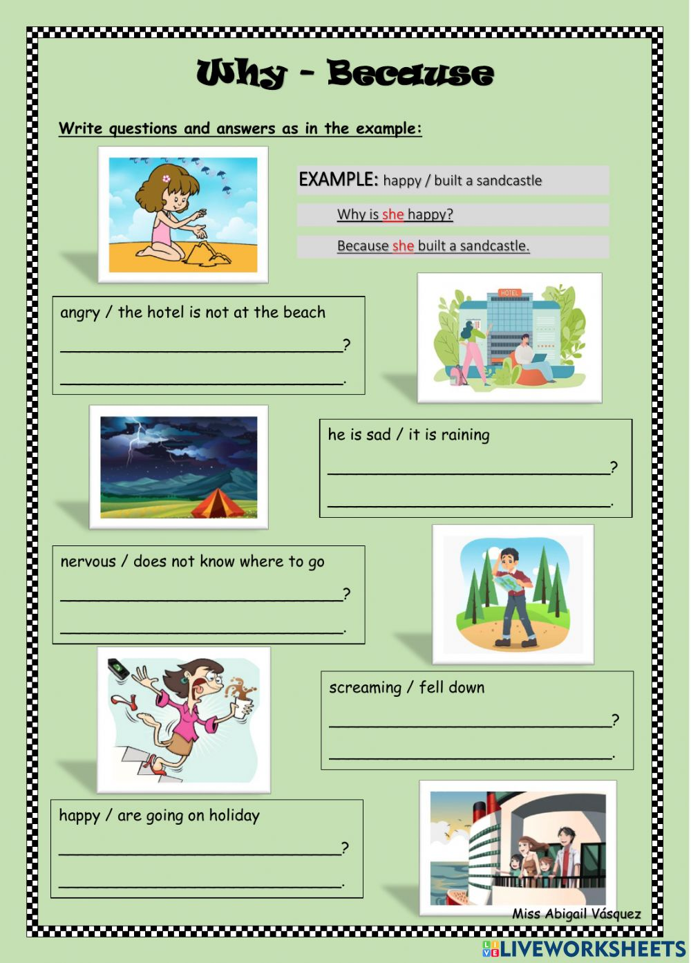
WORKSHOP NUMBER 3
NAME LEVEL

TOPIC : TRAVEL AND MEANS OF TRANPORTATION
WORKSHOP NUMBER 4
Read this and then choose the best answer—lea la lectura y escoja las mejores respuestas.
40 points ( 8 puntos cada respuesta)

ESL Travel Reading

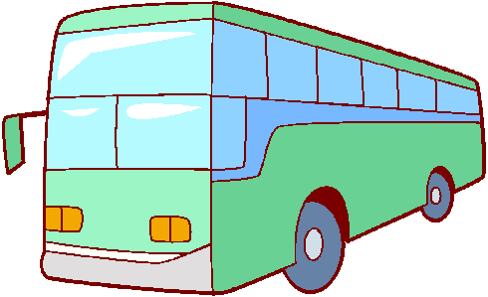

ESL Travel Reading Comprehension Passage
Travel is something which people do every day. It is very difficult to avoid the need to travel. It may be a trip to school, university or to work. Travelling can often take a long time, especially when great distances need to be covered. People often enjoy travelling abroad for holidays. But for some people travelling is not fun at all. Some people suffer from travel sickness. This means that they will become very unwell each time they travel.
Travelling can be either affordable or costly. It often depends on how far you want to travel and the choice of transport. Using a bicycle will not cost anything as you power it by using your legs. However, the use of a bicycle can be hard work and can take a lot of time to travel long distances. Cars and motorcycles are faster modes of transport, but are more expensive to use as gasoline is needed for them to work. It can usually be assumed that the longer you wish to travel, the more expensive and time consuming it will be.
The use of a plane is necessary for people wanting to travel very long distances. A pilot will fly a plane from an airport for many thousands of miles to take people to places far away. Although traffic is rarely a problem for airplanes, it can take a lot of preparation to travel by plane. People often need to arrive at the airport three hours prior to departure.
A train is another mode of transport which is ideal for travelling long distances within the same country, or between countries which are connected by land. A train driver will stop at train stations on route to allow passengers wishing to proceed to the scheduled destination to board the train.
A number of destinations can be travelled to by using the sea. People often depart from a harbour in a ferry which is driven by a captain. If the journey is a long distance, people may choose to sleep on the ferry while they wait to arrive at their destination. Some people choose to go on a cruise for their holiday, which would involve stopping at many different city ports for a short amount of time. People who need to travel short distances may choose not to use any transport at all. People often rely on their legs to take them to places nearby. This is often encouraged as certain modes of transport have been said to produce harmful emissions and damage the environment.

WORKSHOP NUMBER 4
Reading comprehension questions that go with the above reading passage.

1) Which mode of transport does not cost money?
A) Train
B) Car
C) Walking
D) Bus
2) Why do some people not enjoy travelling?
A) They find it a waste of time
B) It is not comfortable
C) It is expensive
D) They become unwell
3) Name the mode of transport which is controlled by a pilot and stops at an airport.
A) Train
B) Airplane
C) Car
D) Bus
4) Name the mode of transport which is controlled by a captain and stops at a port.
A) Train
B) Car
C) Ship
D) Airplane
5) Which mode of transport is ideal for travelling between countries connected by land?
A) Bicycle
B) Train
C) Airplane
D) Car

RESEARCH ABOUT TRAVEL AND TOURISM IN PANAMA
WORKSHOP NUMBER 5
40 points ( each answer is two points)
Research and mention the following :
3 five starts hotels in Panama
2 hostels for backpackers
3 Panamanian airports
1 Fancy restaurant that serves typical Panamanian dishes in our country
2 Places where tourists can exchange money ( from euros, pounds, colones, pesos, yens, etc to American dollars)
3 means of transportation that tourists can use in Panama
3 Museums that tourists can visit
3 Sights of interest in Panama
THIS RESEARCH IS HANDWRITTEN or PRINTED (Include a couple of illustration if possible) --- Investigación escrita a mano o con medios electrónicos (ilustrar si es posible)

TOPIC NUMBER 5
THE IMPORTANCE OF THE ENGLISH LANGUAGE
Workshop number 6
Read the article about the importance of the English language. Look up the meaning of the 15 words and read the article again. Then answer the 5 questions.
Score: Vocabulary 15 points
5 points each answer of the questionnaire and remember that spelling and grammar will be taken into account. (There are 5 questions). So this a 40-point workshop.

Lea el artículo acerca de la importancia de la lengua inglesa. Luego busque las 15 palabras en el diccionario y vuelva a leer el artículo. Recuerde que algunas repuestas son subjetivas y otras objetivas.
Puntuación: 15 puntos el vocabulario y 5 puntos cada respuesta ( 40 puntos en total)

THE IMPORTANCE OF THE ENGLISH LANGUAGE IN PANAMA AND AROUND THE WORLD
English language has become essential in Panama due to its economic development. The construction of The Panama Canal brought many English speaking people to Panama increasing job opportunities, but at the same time this increased job requirements. Many people in Panama have started to learn English to get better jobs such as translators, tours guides, teachers and many other jobs that requires a good level of English.
English is official language of 67 countries. With a good level of English, you can travel around the World and understand other cultures. Even if you are in a country where English is not the official language, you are going to find many people who understand English, so you are not going to get lost. Also, you are going to find announcements, emergency information and street signs in English. Anytime you want to hang out in a foreign country where English is not the first language, you can make friends easily just knowing English.

VOCABULARY
-LANGUAGE 2-JOB
3-LEARN 4- TOUR GUIDE
5- BILINGUAL 6- HELP
7- SUCCESS 8- SINCE
9- WORLD 10- LIFESTYLES
11- NEED 12- DEVELOP
13- FOREIGNERS 14- IN ORDER TO
15- FIRST LANGUAGE
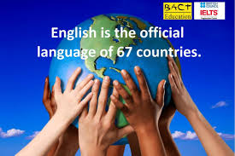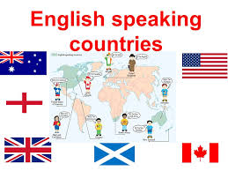

ANSWER THE FOLLOWING QUESTIONS
1--Why do you believe English has become essential in Panama?

2- Why do you think many Panamanians decided to learn English?

3- Why do you think it is so important to speak English FOR YOU? WITH YOUR OWN WORDS.
4- How many countries have English as their official language?

5- Name 5 countries which use English as their official language.

ESTE WORKSHOP INCLUYE
UN VOCABULARIO Y 5 PREGUNTAS

