MEDUCA
IPT MÉXICO-PANAMÁ
GUIDES OF WORKSHOP FOR THE REST OF THE SECOND TRIMESTER
GUÍA DE INGLÉSDEL TERCER TRIMESTRE 2022
11ª GRADES SCIENCE G
TEACHER: JOSÉ VILAS
CONTACTO: CELLPHONE: 66457856
CORREO ELECTRÓNICO : josevilas189@gmail.com
FECHAS DE ENTREGA:

WORKSHOP COMPOSITION PERSONALITY AND TRAITS PRIMER DÍA QUE NOS VEAMOS EN EL SALÓN DE CLASES.
WORKSHOP 3 y 4 | El primer día que nos veamos en clase
WORKSHOP 1, 2 ,5 | El día 15 de noviembre
WORKSHOPS 6, 7 y 8 | El día 12 de diciembre
Ejercicio sobre Healthy food | Segundo día que asistan a clases
ENTREGA DE TRABAJOS PENDIENTES (Favor presentar excusa de su acudiente que justifique la entrega tardía.) | Los días 16, 19 y 20 de diciembre

TOPICS
Holidays around the world:
-Religious/Popular/Traditional

Personality traits

The importance of
healthy habits for self-
caring.
- healthy / junk food

Exercise / sports and health

TOPIC
HOLIDAYS IN PANAMA AND AROUND THE WORLD
Review of writing dates –Repaso de como escribir fechas
 | American English
numbers and letters | May 7, 2013

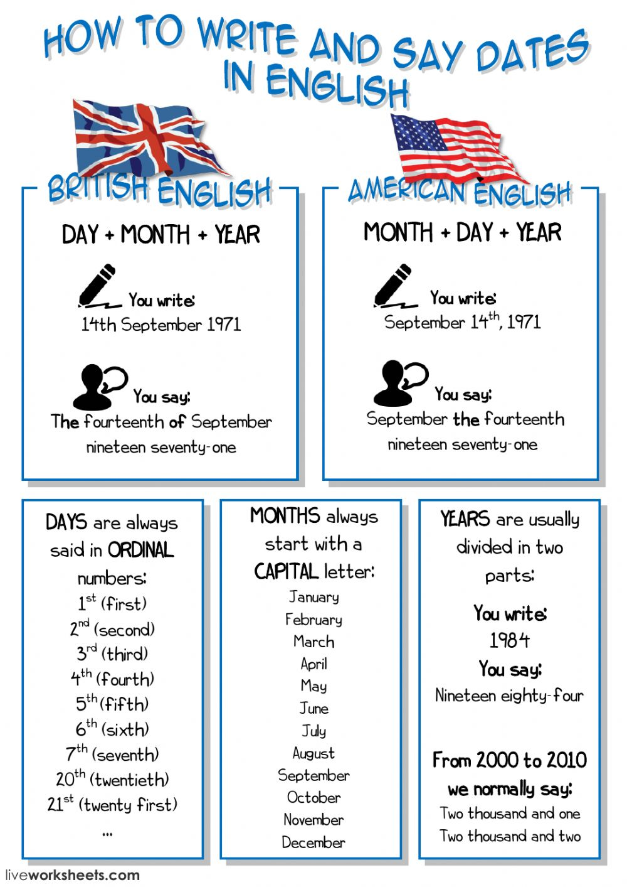
WORKSHOP NUMBER 1
Write in American English the dates when this International Holydays are celebrated, some are on lists below.
Escriba el nombre de 8 días festivos a nivel internacional. Abajo aparecen varios. Para los días festivos movibles escriba las fechas del presente año.
For example : Navidad = Christmas = December 25th
40 points ( 5 points each answer)
Año nuevo =
Víspera de año nuevo =
Día del trabajo =
Dia de San Valentín =
Viernes Santos=
Sábado de Gloria =
Domingo de Pascua =
Noche Buena =
Jueves Santo=

WORKSHOP NUMBER 2
OF THE LIST CHOOSE 8 DAYS THAT ARE JUST
HOLIDAYS IN PANAMA
TRANSLATE THEN AND WRITE THE DATES
DE LA LISTA ESCOGE 8 HOLYDAYS QUE SON EXCLUSIVOS DE PANAMÁ Y ESCRIBE SU TRADUCIÓN Y CUANDO SE CELEBRAN
INCLUIR St. Christopher’s Day y el que puso de ejemplo
40 POINTS ( 5 POINTS EACH ANSWER)
For example: Marty`s Day= Día de los martires = January 9th

TOPICS
PERSONALITY AND TRAITS
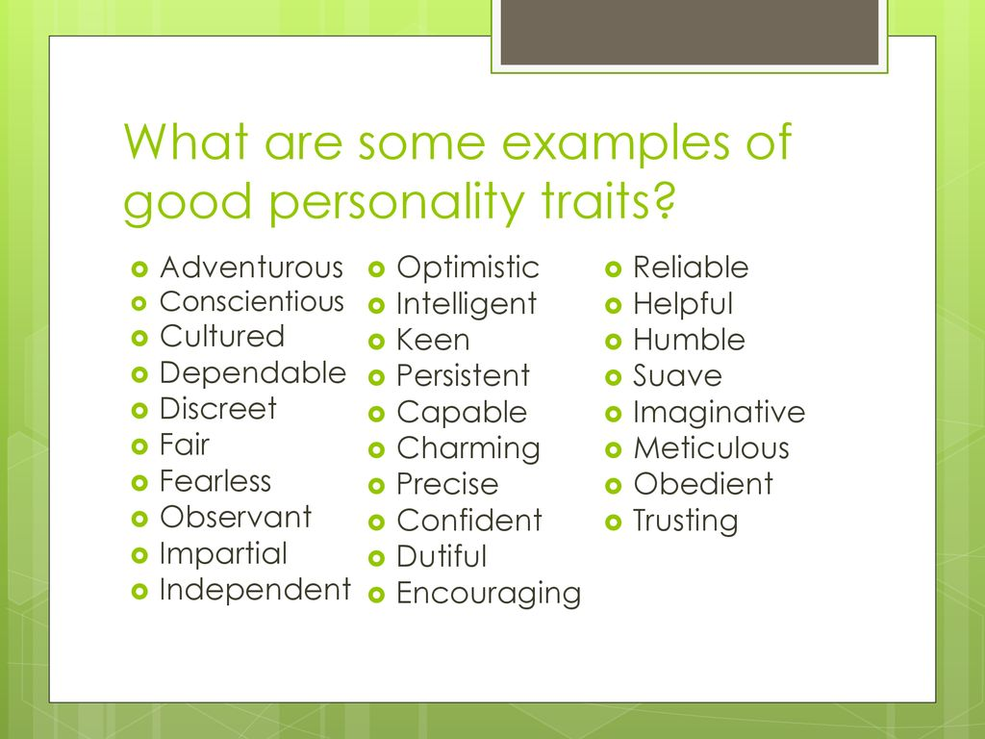
In the chart above there are some adjectives to describe your personality and traits, with this information you are going to do the next two workshops

WORKSHOP NUMBER 3
TRANSLATE 20 ADJECTIVES TO DESCRIBE PERSONALITY AND TRAITS FROM THE CHART BELOW
TRADUZCA 20 ADJETIVOS DEL CUADRO ANTERIOR PARA DESCRIBIR LA PERSONALIDAD
40 points ( 2 points each translation)

WORKSHOP NUMBER 4
WRITE A SMALL COMPOSITION ABOUT YOUR PERSONALITY AND TRAITS and TWO MEMBERS OF YOUR FAMILY
YOU CAN USE THE ADJECTIVE BELOW BUT ALSO OTHER ADJECTIVES.
REMEMBER TO USE CONNECTION WORD SUCH AS: BESIDES , ALSO , FURTHERMORE.
For example: I am fearless, and charming. Besides, I am …..
You need to use 5 adjectives to describe you and the other member of your family.
40 points
Remember to use good grammar and spelling because they will be taken into account for grading.
OBSERVACIÓN: ESTA WORKSHOP EN PARTICULAR SERÁ GUIADA POR EL TEACHER EN SU PRIMERA CLASE

Topic : HEALTHY FOOD
READING

- Make most of your meal vegetables and fruits – ½ of your plate:Aim for color and variety, and remember that potatoes don’t count as vegetables on the Healthy Eating Plate because of their negative impact on blood sugar.
- Go for whole grains – ¼ of your plate:Whole and intact grains—whole wheat, barley, wheat berries, quinoa, oats, brown rice, and foods made with them, such as whole wheat pasta—have a milder effect on blood sugar and insulin than white bread, white rice, and other refined grains.
- Protein power – ¼ of your plate: Fish, poultry, beans, and nuts are all healthy, versatile protein sources—they can be mixed into salads, and pair well with vegetables on a plate. Limit red meat, and avoid processed meats such as bacon and sausage.
- Healthy plant oils – in moderation: Choose healthy vegetable oils like olive, canola, soy, corn, sunflower, peanut, and others, and avoid partially hydrogenated oils, which contain unhealthy trans fats. Remember that low-fat does not mean “healthy.”
Drink water, coffee, or tea: Skip sugary drinks, limit milk and dairy products to one to two servings per day, and limit juice to a small glass per day.

WORKSHOP NUMBER 5
FILL IN THE BLANKS AND MAKE A LIST OF 10 HEALTHY FOOD AND TEN UNHEALTHY FOOD
40 POINTS ( THE FIIL IN THE BLANK IS 2O POINTS
AND THE LIST 20 POINTS)

1-NUTRIENTS PROVIDE _____________ TO OUR BODY.
2. -OUR PHYSICAL FITNESS DEPENDS ON WHAT WE ____________.
3.- THE STUDY OF NUTRIENTS IN OUR BODY IS
CALLED__________________.
4. -GOOD EATING HABITS DEPEND ON EATING THREE_____________ A DAY.
5.- CHANGING OUR EATING HABITS IS NOT___________
6- THE THREE IMPORTANT MEALS ARE ________________________,
__________________, AND ___________________.
7- A QUARTER OF YOUR DISH SHOULD INCLUDE_______________
8- HOW MUCH JUICE SHOULD YOU DRINK PER DAY___________

Name 10 healthy food and 10 unhealthy food AND THEN FILL IN THE BLANKS. The list is ten points and the fill in the blank values 30 points. Escribe 10 alimentos saludables ( healthy) y 10 no saludables ( unhealthy)
Y LUEGO LLENA LOS ESPACIOS DESPUÉS DE LEER LA LECTURA “HEALTHY EATING”
FOR EXAMPLE:
HEALTHY FOOD | JUNK FOOD—UNHEALTHY FOOD
LETTUCE | CANDY
ORANGE | BACON

EXAMPLE OF JUNK FOOD: 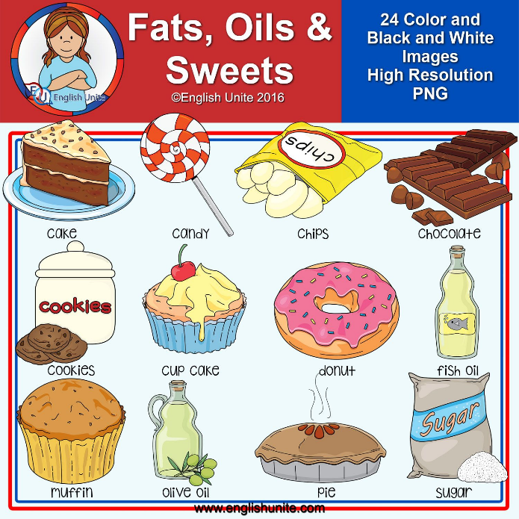

WORKSHOP Nº6
(SCORE : 40 POINTS)
DRAW YOUR ON FOOD PYRAMID. INCLUDE 5 FOODs FOR EACH GROUP , SO THERE SHOULD BE 30 FOODS . DO NOT COPY/ PASTE OR USE A CUT ILLUSTRATION. YOU MUST DRAW YOUR OWN PYRAMID.

DIBUJE LA FOOD PYRAMID--INCLUYA 5 FOODS CON EL NOMBRE EN ENGLISH POR CADA GRUPO ( EN TOTAL SON 30 FOODS DIBUJADOS Y ESCRITOS EL NOMBRE NO PUEDES USAR FIGURAS DE INTERNET , NI DE LIBROS O REVISTAS Y RECUERDA ESCRIBIRLE EL NOMBRE A CADA UNO DE LOS 30 ALIMENTOS EN INGLÉS. ADEMÁS DE LOS NOMBRES DE CADA PARTE DE LA PIRÁMIDE: GRAINS, FRUITS, ETC.

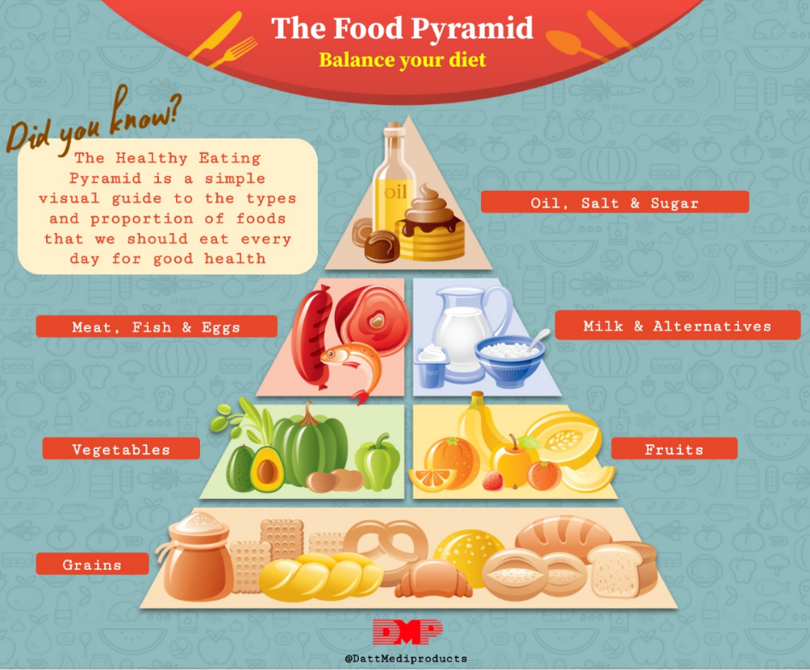

REMEMBER THAT YOU MUST DO AND DRAW YOUR OWN FOOD PYRAMID.
RECUERDA QUE DEBES DIBUJAR TU PROPIA FOOD PYRAMID CON LAS INDICACIONES CORRESPONDIENTES

TOPIC
SPORT AND HEALTH
WORKSHOP NUMBER 7
UNSCRAMBLE THE SPORTS , DO THE MATCH THEN ANSWER THE TWO QUESTIONS.

DESENREDE LAS PALABRAS, POR EJEMPLO:
1- aolfblot = football
2-bbaalelstk = basketball
Después, haga el match
Luego contesta las dos preguntas en inglés.
1- What sports do you like?

I like…...
2-Do you practice any sport?

I practice…….

40 points ( 5 points each answer and 30 points the list sport activity)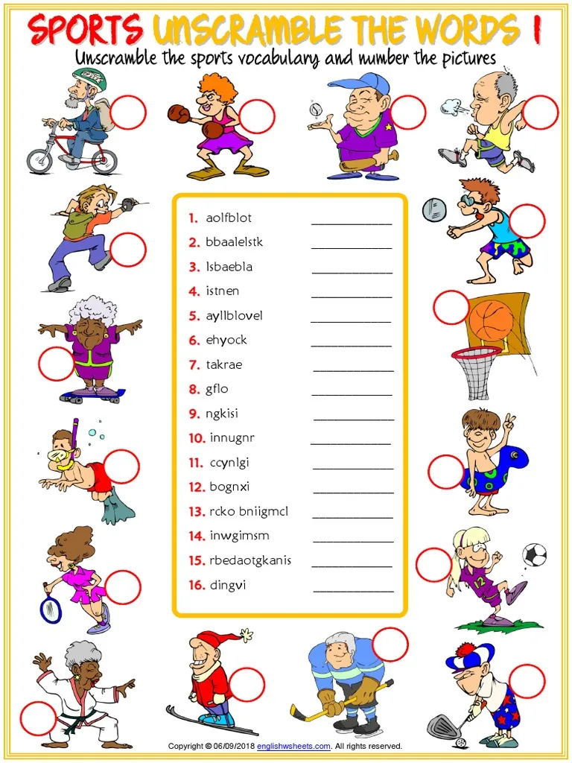
Workshop Number 8
With the help of a dictionary and the guidance of the teacher try to understand the reading below and answer the true or false
This is a 40-point activity ( each answer is 5 points)
Remember to write your name and level on the page too

