2022
I.P.T MEXICO PANAMA

Profesor: Edgar Asprilla
6334-9319
MODULO DE INGLES
II TRIMESTRE

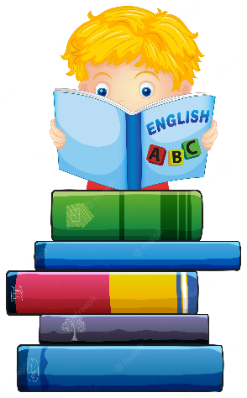
NIVEL:
7° ______

ESTUDIANTE _________________________________________________

FECHA DE ENTREGA
21 DE NOVIEMBRE AL 2 DE DICIEMBRE, 2022
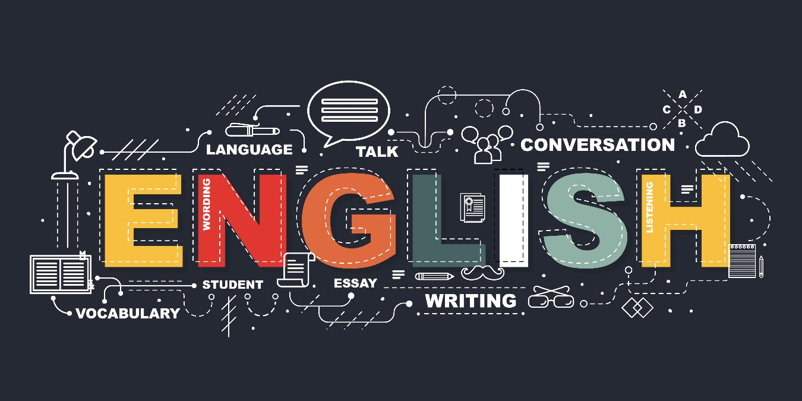

- RECREATION AND SPORTS
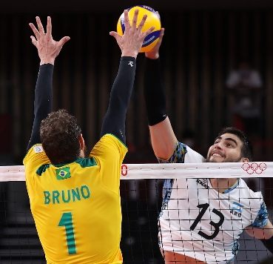
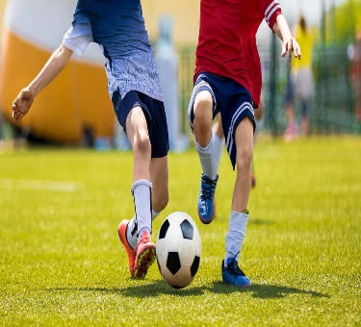
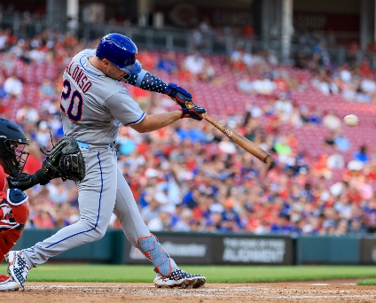

Recreational activities are done for enjoyment, peasure or fun when one is not working

Sports are activities thet involve enjoyment, recreation, exercise our entertaiment in group or individually.

Here is a list of some sports:

Baseball is a sport played by two competitor teams. The players have to hit a samall round ball with a bat and run to score points.

Football is a sport played among two teams. Each team tries to carry, pass or kick a pointed oval down the field of the opposing team to score points.

Swimming is the movement of humans through wáter. This activity is good fo exercise and relaxation.

Basketball is a sport base don two teams dribbling or passing a round ball with their hands to make a basket through a netted hoop.

- ACTIVITY # 1

Answer the following questions. (10 points)

- How do you play baseball? _________________________________________
- What are different shapes of the balls for the different sports?
________________________________________________________________
- Who is your role model in sports? ____________________________________
- How do you play basketball? ________________________________________
- What is the difference between soccer and football?
__________________________________________.

- HOLIDAYS
Holidays are celebrations accepted by law to commemorate special happening is a country. They can be cultural, social, religious or other events that are celebrated every year.
People usually don´t work during some specific holidays, since they get together to enjoyo remember their customs and traditions.
Thanksgiving Halloween New Year´s Day
Father´s Day Valentine´s Day All Soul´s Day
Independence Day Carnival
Mother´s Day Christmas

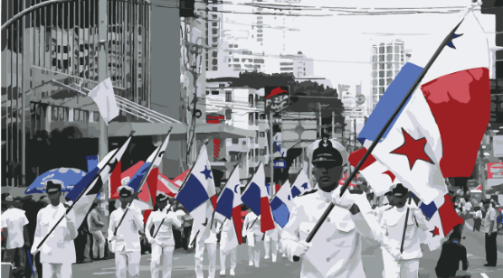
- HOLIDAYS EN AMERICA

What holidays do we celebrate in Panama? What holidays are celebrated in America? ¿Are holidays celebrated on the same day everywhere?

Every country has especial days they call holidays. Everyone likes holidays because they are times we spend with our families and Friends celebrating different events. Holidays are fun.

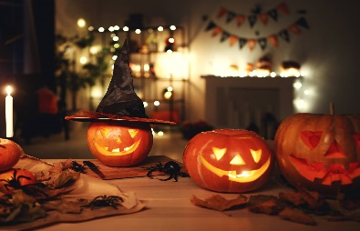

Halloween is october 31st . people wear costumes and have parties for this celebrations.
Labor Day is May 1st celebrated primarily in many latinamerican countries.

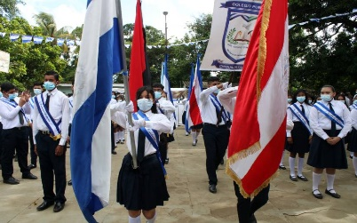
New Year is January 1st . People celebrate with Fireworks, parties firecracks and New years´s eve dinner.
In Panama, Mother´s Day is December 8th . people give presents to their mother and to other relatives.
Independence Day is the birthday of the country. In Panama, parades of bands march through the streets.

- ACTIVITY #2
- Complete the following sentences according to the next. (14 points)

- Each community has a date to celebrate or commemorate a ____________
- _________________________ are thoughts, practices or behavior accepted by people of a region.
- People have been passing down ________________________ from generation to generation.
- What the meaning of Independence Day? __________________________
- Mention three holidays ____________________________, _________________________, ________________________________.

- Make a list of all the holidays in the year. Rank them according to your most favorite (No. 1) and least favorite. With your classmate, talk about your most favorite holidays and least favorite and why. (12 points).

Month | Name of Holiday
January 1st | New Year´s Day

- Choose one holidays and write a paragraph explaining why it is your favorite holiday. (5 points)

_______________________________________________________________________________________________________________________________________________________________________________________________________________________________________________________________________________________________________________________________________________________________________________________________________________________________________________________________________________________________________________________________________________________________________________________________________________________________________________________________________________________________

- DIALOGUE #1
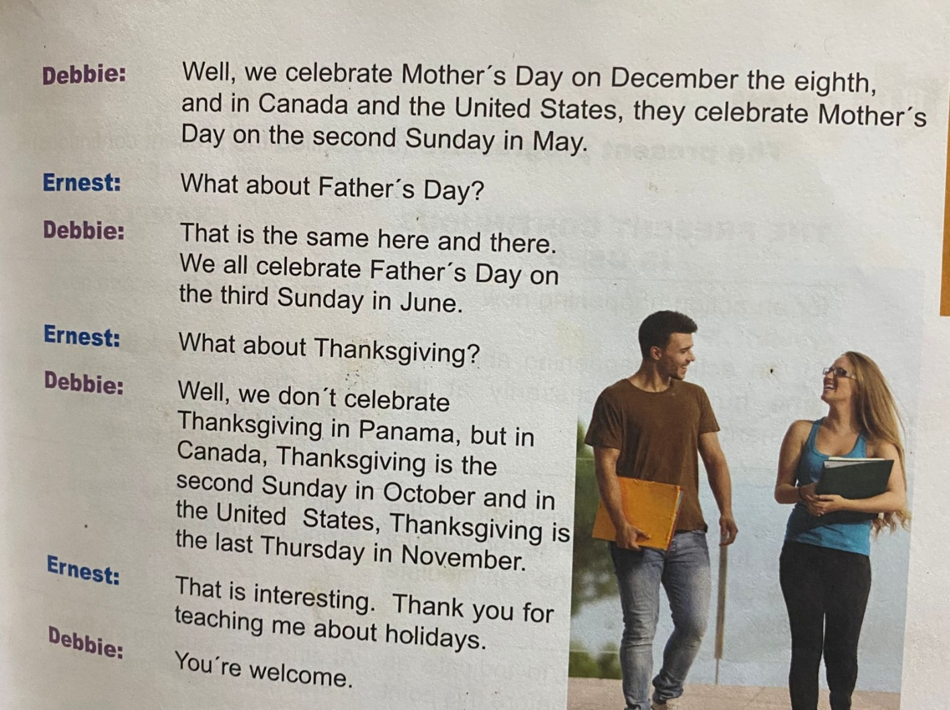
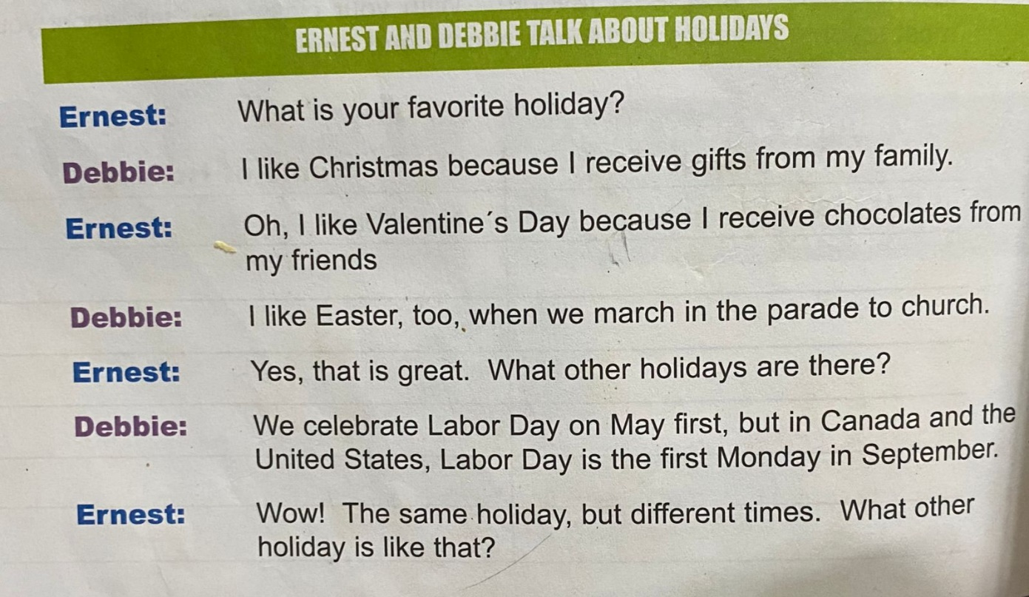

- QUESTION ABOUT THE DIALOGUE
(14 POINTS)

- What happens in the dialogue?
_____________________________________________________________
- What is Debbie´s favorite holiday?
____________________________________________________________
- Why?
____________________________________________________________
- What is Ernest´s favorite holiday?
____________________________________________________________
- Why?
____________________________________________________________
- Why does Debbie like Easter?
____________________________________________________________
- When is Labor Day in Panama?
____________________________________________________________
- When is Labor Day in the United States?
____________________________________________________________
- When is Mother´s Day in Panama?
____________________________________________________________
- When is Mother´s Day in the united States?
____________________________________________________________
- When is Thanksgiving in Canada?
____________________________________________________________
- When is Thanksgiving in the United States?
____________________________________________________________
- What is your favorite holiday?
____________________________________________________________
- Why?
____________________________________________________________

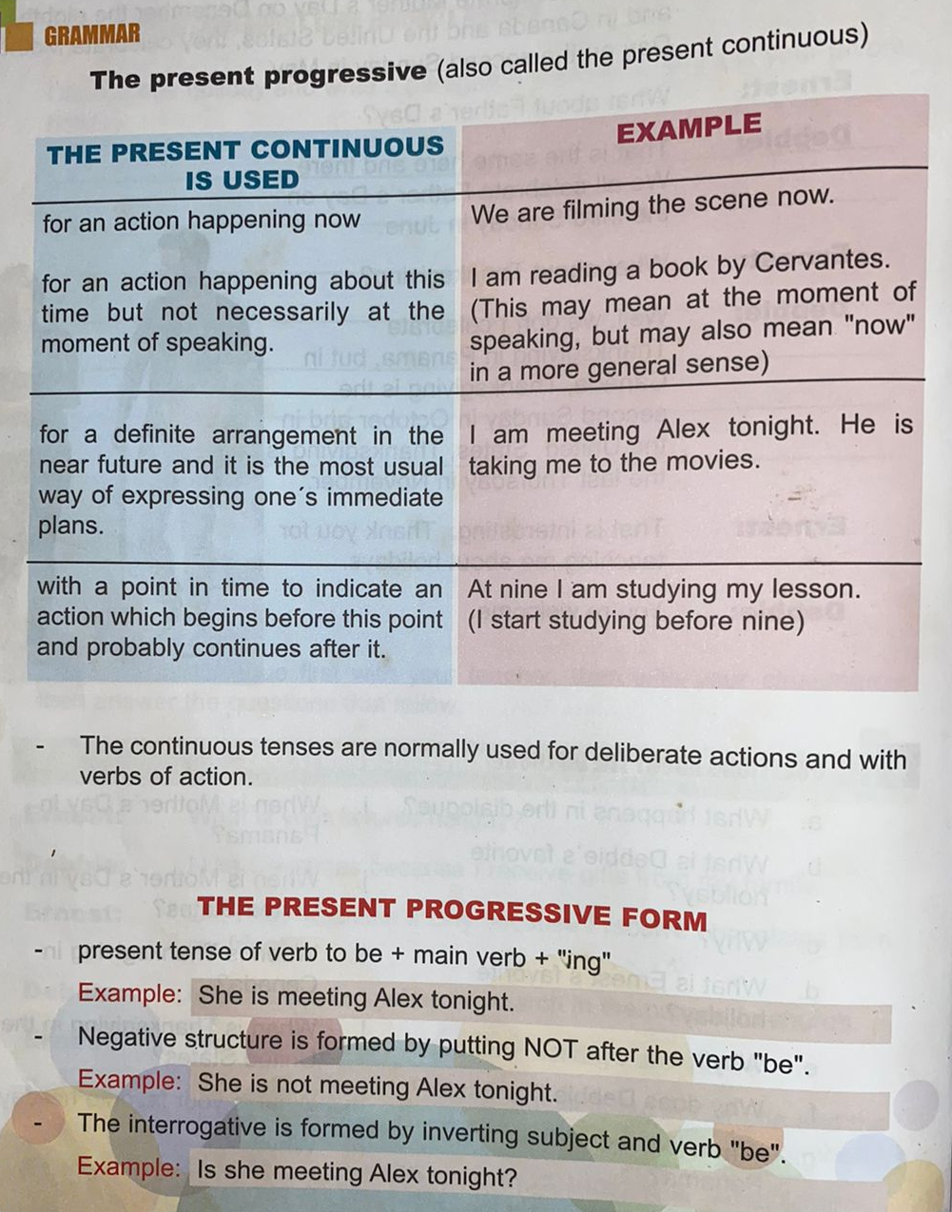

- Practice #1

- Fill in the blanks with the correct form of the verb. (10 points)
Example: She is watching TV. ( watch)

- We are _______________________ a book. (read)
- He is _________________________ his bicycle. (fix)
- I am __________________________for a test. (study)
- She ___________________________ the dishes. (wash)
- You __________________________ your room. (clean)
- They _________________________ the house. (Paint)
- It _________________________ outside. (rain)
- Bob an Mary _________________ to school. (walk)
- I _____________________ lunch. (eat)
- You ____________________ to the teacher. (listen)

- Write a paragraph about yourself. (5 points)
Now write three sentences that describe three things that you are doing right now.

_______________________________________________________________________________________________________________________________________________________________________________________

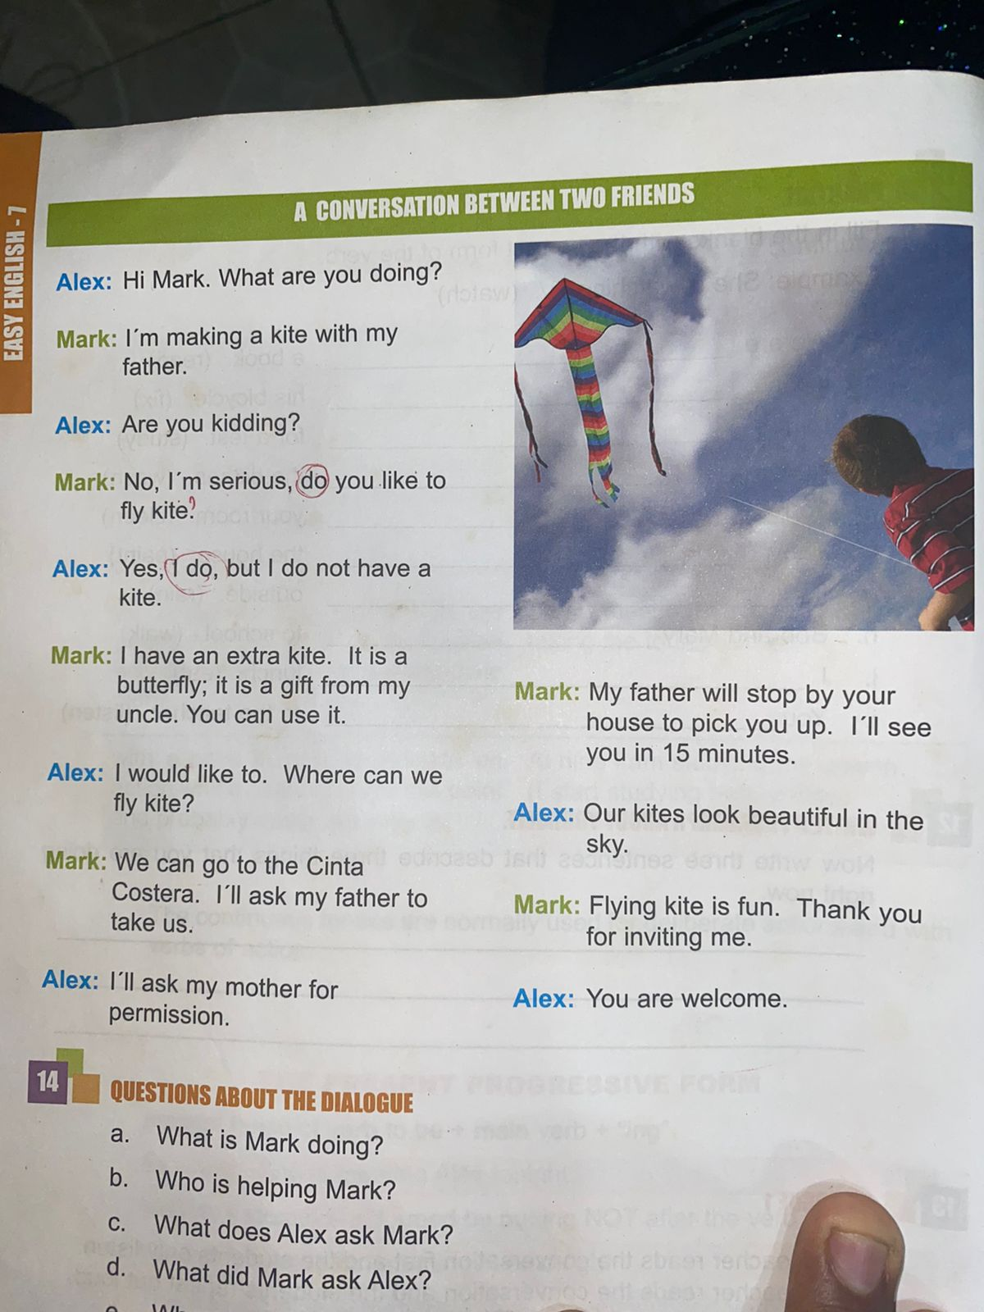
- DIALOGUE #2

- QUESTIONS ABOUT THE DIALOGUE.

- What is Mark doing?
_____________________________________________________

- Who is helping Mark?
____________________________________________________

- What does Alex ask Mark?
____________________________________________________

- What did Mark ask Alex?
____________________________________________________

- Where are Mark and Alex going to fly kite?
____________________________________________________

- Who is taking them there?
___________________________________________________

- What did the boys consider fun?
____________________________________________________
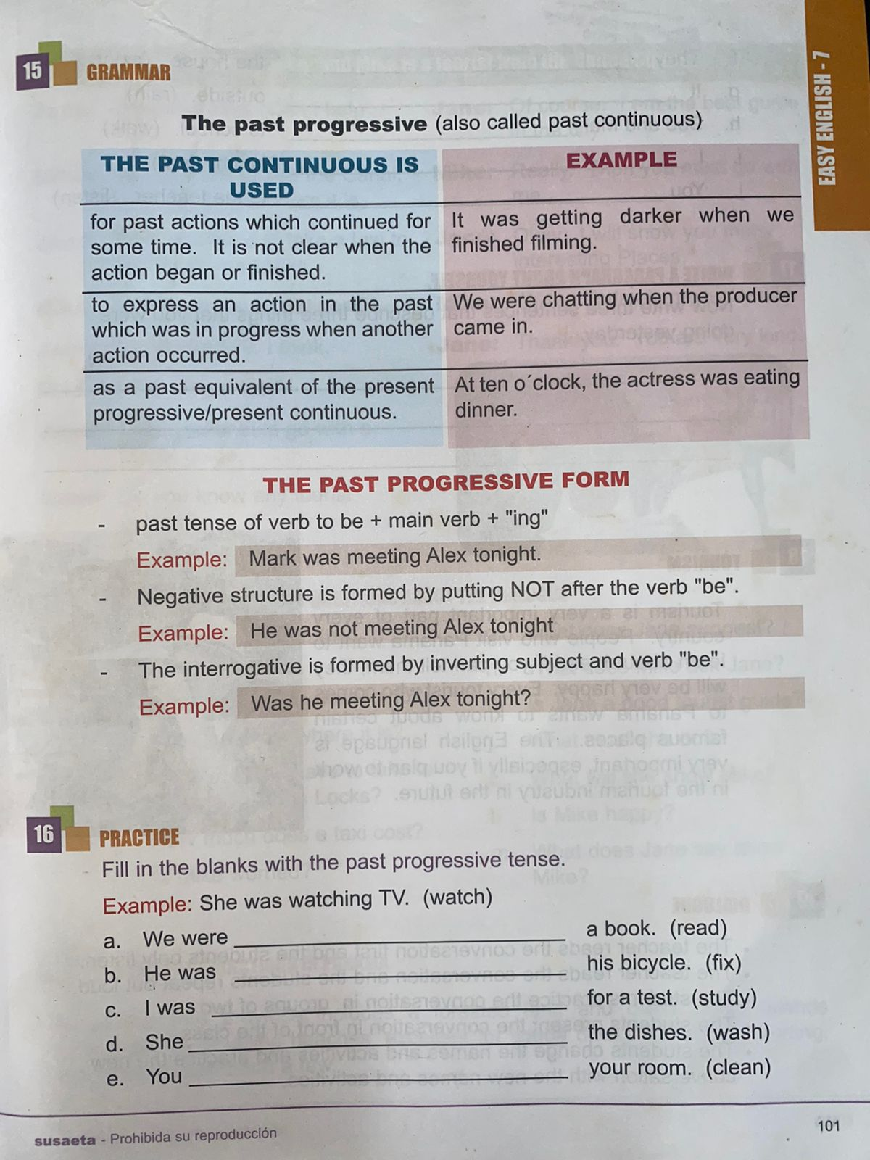

- PRACTICE #2
Fill in the blanks with the past progressive tense. (10 points)
Example: She was watching TV. (watch)

- We were _______________________ a book. (read)
- He was _________________________ his bicycle. (fix)
- I awas __________________________for a test. (study)
- She ___________________________ the dishes. (wash)
- You __________________________ your room. (clean)
- They _________________________ the house. (Paint)
- It _________________________ outside. (rain)
- Bob an Mary _________________ to school. (walk)
- I _____________________ lunch. (eat)
- You ____________________ to the teacher. (listen)

Write a paragraph about yourself. (5 points)
Now write three sentences that describe three things that you were doing yestreday.
___________________________________________________________________________________________________________________________________________________________________________________________________________________________

A goal without a plan
is just a wish

Test #1

THE PRESENT CONTINUOUS

Name: _______________ Level: ____________ Date: _____________

- Fill in the blanks with the present progressive tense. (5 points)

- We are _______________________ a book. (read)
- He is _________________________ his bicycle. (fix)
- I am __________________________for a test. (study)
- She ___________________________ the dishes. (wash)
- You __________________________ your room. (clean)

- Transcribe these sentences present progressive to negative and interrogative. (6 points)
- He is painting the house.
- Bob and Mary are to school.
- I am eating lunch.

NEGATIVE
- _______________________________________
- _______________________________________
- _______________________________________

INTERROGATIVE
- ________________________________________
- ________________________________________
- ________________________________________

Test #2

THE PAST CONTINUOUS

Name: _______________ Level: ____________ Date: _____________

- Fill in the blanks with the past progressive tense. (5 points)

- We were______________________ a newspaper. (read)
- He was_________________________ his bicycle. (fix)
- I was __________________________for a test. (study)
- She ___________________________ the dishes. (wash)
- You __________________________ your bag. (clean)

- Transcribe these sentences to past contiuous to negative and interrogative sentences. (6 points)
- He is painting the house.
- Bob and Mary were to school.
- I was eating lunch.

NEGATIVE
- ______________________________________
- _______________________________________
- _______________________________________

INTERROGATIVE
- ________________________________________
- ________________________________________
- ________________________________________

Rubrica de evaluación
 | Activity #1 | Activity  #2 | Dialogue  #1 | Practice #1 | Dialogue #2 | Practice # 2 | Test  #1 | Test  #2
Excelente | 10pts | 30pts | 14 pts | 15 pts | 7 pts | 15 pts | 11 pts | 15 pts
Bueno | 8pts | 28 pts | 12 pts | 13 pts | 6pts | 13 pts | 10 pts | 13 pts
Por mejorar | 5pts | 15 pts | 9 pts | 8 pts | 4 pts | 8 pts | 5pts | 8pts
No satisface | 0-4pts | 0-14 pts | 0-6 pts | 0-7 pts | 0-3 pts | 0-7 pts | 0-5 pts | 0-7 pts

