Ministerio de Educacion
Dirección Regional de Educacion de Panamá
Región Educativa de Panamá Este

I.P.T. México - Panamá

Guía de Ingles
Tercer Trimestre
Nivel 11°________
Bachiller Agropecuario / Ciencia

Nombre del Estudiante: _________________________________
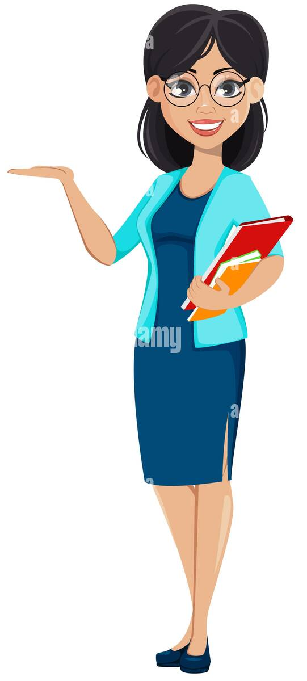
Profesora: Cristela Calderón
Teléfono: 63841271
Correo: cr1st3la22@gmail.com

Año lectivo 2022.

OBJETIVO GENERAL NIVEL 11°
Manejar la gramática inglesa de tal manera que le permita sustentar la complementación de estructuras, el cuestionamiento y respuestas en diferentes tiempos verbales a través de talleres, lecturas comprensivas permitiéndoles la adquisición permanente del conocimiento gramatical de esta lengua importante en este mundo globalizado.

TOPICS
1-Avoiding pollution to Conserve our nature.
  - Types of Pollution and causes
  - Vocabulary
  - Reading Comprehension
  - Grammar
- Reported Speech
- Modals (Should, Shouldn´t / must, mustn´t / have to.
2- The importance of healthy habits for self- caring.
2.1. Reading Comprehension
2.2. Food Pyramid
2.3. Grammar
    - Gerunds and infinitives
    - Phrasal Verbs
3- Cultural diversity in Panama.
3.1. Reading Comprehension
3.2. Ethnic Groups in Panama
3.3. Grammar
- Tag Questions

1-Avoiding pollution to conserve our nature.
  - Types of Pollution and Causes.
Complete the table below with the information from the text:
There are lots of environment problems nowadays, mainly because of pollution. It is the contamination of air, water and land by waste, chemicals, smoke and other harmful substances.
The emission of smoke from factories and cars, are big causes of air pollution which produce acid rain, smog and a hole in the ozone layer.
Water is also suffering from pollution because of the millions of tons of litter being thrown into the seas every year.
Pollution is also caused by the fertilizers and pesticides used by farmers for the soil.
It is up to us to stop damaging the environment. We all should act green and fight the pollution by using 3 R´s!

Types of pollution Causes
_____________________________ _______________________________
_____________________________ _______________________________
_____________________________ ________________________________

Vocabulary
Translate the following words and illustrate them.20pts
- Air pollution _________________________

- Water pollution __________________________

- Soil pollution ___________________________

- Noise pollution __________________________

- Landfills ____________________________

- Wildlife _______________________________

- Pesticide ______________________________

- Plastic pollution ___________________________

- Light pollution ___________________________

- Thermal pollution __________________________

  - Reading Comprehension
Pollution is the introduction of contaminants into the natural environment that cause adverse change. Pollution can take form of chemical substances or energy, such as noise, heat or light. Pollutants, the components of pollution, can be either foreign substances/ energies or naturally occurring contaminants. Pollution control is a term used in environmental management. It means the control of emissions and effluents into the air, water or soil. Without pollution control, the waste products from overconsumption, heating, agriculture, mining, manufacturing, transportation and other human activities whether they accumulate or disperse, will degrade the environment. To protect the environment from adverse effects of pollution, many nations worldwide have enacted legislation to regulate various types of pollution.

After reading several times, answer the following questions.24pts
1. What is the title of the reading? _________________________________________
2. What forms pollution can take?
____________________________ and _____________________________
3. Mention some of the chemical or energy forms in our environment?
_________________________, ______________________,_____________________

4. Mention five environmental pollution in the world?
________________________________ , ___________________________ , ___________________________ , ____________________________, _______________________________.
5. How can we prevent the pollution?
_________________________________________________________________________

1.3.GRAMAR
- Reported Speech
Reported speech is when we tell someone what another person said. To do this, we can use direct speech or indirect speech.

Direct speech: 'I work in a bank,' said Daniel.
Indirect speech: Daniel said that he worked in a bank.

En los siguientes ejemplos verás que al pasar una oración a estilo indirecto se producen algunos cambios:

Direct speech (Estilo directo): | Reported speech o (estilo indirecto):
1. I am happy to drive you to the airport.  (Me alegra llevarte en coche al aeropuerto.) | 1.She said she was happy to drive me to the airport.  (Dijo que se alegraba de llevarme al aeropuerto)
Es necesario adaptar los pronombres personales, de acuerdo con la persona a la que se refieran y a la que esté hablando. También se modifica el tiempo verbal en función de cuál sea su relación con el momento actual, lo que generalmente implica trasladarlo al pasado (por ejemplo, del present simple al past simple, como en la oración anterior)
Así pues, ¿cómo cambia el verbo en el reported speech? En las siguientes tablas encontrarás algunos ejemplos:
Estilo directo (present simple) | Estilo indirecto o reported speech (past simple)
I know what to do (Sé lo que hay que hacer) | She said she knew what to do (Dijo que sabía lo que había que hacer)
I don’t know what to do (No sé qué hay que hacer) | She said she didn’t know what to do (Dijo que no sabía lo que había que hacer)

Estilo directo (present continuous) | Estilo indirecto o reported speech (past continuous)
1.I’m working on it this week (Estoy trabajando en ello esta semana). | 1.He said he was working on it this week* (Dijo que estaba trabajando en ello esta semana).
2.I’m not working on it this week (No estoy trabajando en ello esta semana) | 2.He said he wasn’t working on it this week (Dijo que no estaba trabajando en ello esta semana).

Now is your time to practice
Practice
Choose the correct form to complete the sentences below using Reported Speech.
- Carlos: "He works in a bank." He said that _________________________________
- Daniel: "I'm coming!" He said that ______________________________________
- Susan: "I go to the party." She said that ___________________________________
- Nadja: "I don't like chocolate." She said that _______________________________
- Daniela: "She's living in Paris for a few months." She said that _________________
- Eduard: "I visit my parents at the weekend." He said that _____________________
7. Jessica: "I play football in the garden." Jessica told me ________________________
8. She: "I sing that song." __________________________________________________
9. Hanna: "I am going to the cinema." _______________________________________
10. Andrew: "Wash the dishes."____________________________________________
11. Jessica: "Writes a letter." _______________________________________________
12. Sarah: "Helps Peter's sister." ____________________________________________
13. Anna: "Open the window." _____________________________________________
14. Helen: "I am writing a letter.” ___________________________________________

- Modals (Should, Shouldn´t / must, mustn´t / have to.
Present | Positive | Negative
have to /  don't have to | Strong obligation (possibly from outside)  - 1. Children have to go to school.  (sometimes 'have got to') | No obligation  - 1. I don't have to work on Sundays.  2. You don't have to eat anything you don't like.
must / mustn't | Strong obligation (possibly based on the speaker's opinion)  - 1. I must study today. | Negative obligation  - 1.You mustn't smoke here.
should / shouldn't | Mild obligation or advice  - 1. You should save some money. | Mild negative obligation or advice  - 1.You shouldn't smoke so much.

Now is time to practice. Complete the sentences using should, shouldn’t, must, mustn’t, have to, don´t have to.
(1) We _______ look after our environment to prevent pollution.
(2) Villagers living along rivers ________ throw rubbish into them.
(3) Picnickers ______ put plastic bottles into the bins and not litter the beach.
(4) The beaches ________ become polluted if we want tourists to visit them.
(5) For tourists to visit Bali, the island ________ be kept clean and green.
(6) We _______ cut down trees as it will cause soil erosion.
(7) We _________ pollute our air and water for healthy living.
(8) We _________ pollute water, as this will reduce the amount of clean water in the future.
9. You __________________ smoke in here; smoking is not allowed.
10. Visitors to the zoo ________________________ feed the animals.
Exercise #1
Name: _____________________________ 35pts, score: __________
I- According to the topics learned answer the following questions.
1. What is Pollution? _______________________________________________________
________________________________________________________________________________________________________________________________________________
2. Give examples of how you can prevent pollution.
a.______________________________________________________
b.______________________________________________________
c.______________________________________________________
3. Identify the types of pollution show in the pictures.
_____________________ _____________________ ______________________

_________________________ _________________________

II- Choose the correct form to complete the sentences below using Reported Speech.
  - “I’m very tired”, she said.________________________________________
  - “I’m going to the cinema”, she told me. _____________________________
  - “I see the children quite often”, he said._____________________________
  - “I’m having a bath”, she said._____________________________________
  - “I’m listening to the radio”, he told me _____________________________
  - Anna: “I am studying for my exams.”______________________________
III. Choose the correct option (should, shouldn’t, must, mustn’t, have to, don´t have to)
- People must /mustn´t plant lots of new trees.

- You should / shouldn´t throw rubbish on the ground.
- We must /Mustn´t stop cutting down trees.
- People have to /don’t have to recycle more plastic.
- We should /Shouldn´t use more electric cars to reduce air pollution.
IV. Complete the sentences using should, shouldn’t, must, mustn’t, have to, don´t have to.
- The rivers _____________ be contaminated.
- We ______________ use natural gases.
- Dams and embankments _____________ be created.
- Dead bodies’ ________________ be thrown into the rivers.
- We all _______________ act green and fight the pollution by using 3 R´s!
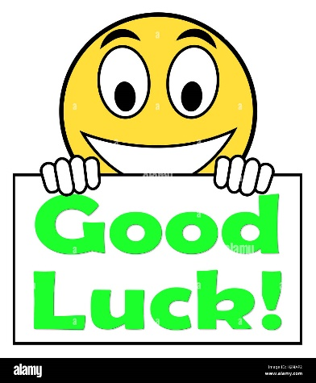

2- The importance of healthy habits for self- caring.
About you… | True | False
1. I like to eat fruits and vegetables.
2. I often drink Coke.
3. I prefer to eat healthy food.
4. I love French fries.
5. I rarely get colds.
6. I often have allergies.
Check the box if the statement is True or False for you.

2.1. Reading Comprehension.24pts
A Healthy Lifestyle
As time goes by, Doctors and Scientists are finding a strong relationship between the mind and the body. It´s becoming clear that have you feel mentally and emotionally is very important for the way you feel physically. Have you ever thought that ones you passed the age of 20 you start to die? Of course, that is generally a slow process, but you can´t escape from it. Teenagers find it difficult- if not impossible- to imagine themselves as middle- aged or old people. That´s because they are young, fit and strong; however, if they don´t get into the habit of taking regular exercise early in life to keep like that as long as possible, they will have lots of problems when they are older. One of the easiest ways to keep fit is to stick to a healthy diet, that is to say, to eat fruit, fresh vegetables and food containing fibre, regularly. Smoking is something you most give up if you want to be healthy. Also, try to reduce your alcohol consumption and avoid being too fat.

- Circle T (True) or F (False).
- There is a relationship between mind and body. T F
- Our body start to die slowly after our twenties. T F
- Teenagers know how old people feel. T F
- Exercising early in life is important. T F
- You will not get any health problems with exercise. T F
- We should keep a healthy diet. T F
- Being fast is ok. T F
- Alcohol is very bad for you. T F
B. Complete the sentences according to the text.
1. The way you feel mentally and emotionally. __________________________
2. It is a slow process. _______________________________
3. If teens don´t do regular exercise, _______________________________
4. Teens should avoid ____________________________________.
2.2. Food Pyramid
A food pyramid is a representation of the optimal number of servings to be eaten each day from each of the basic food groups.
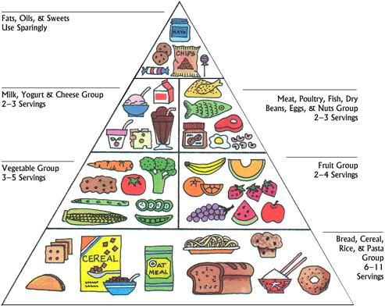

Complete the Reading using the words from the box. 14pts
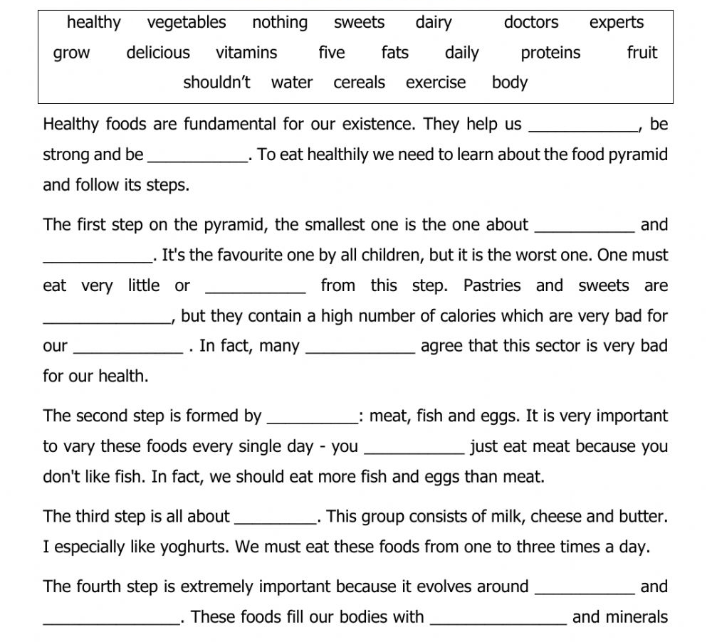
2.3. Grammar
1. Gerunds and infinitives
Infinitives | Gerunds | Rules
An infinitive is the verb form that has “to” at the beginning. For example, “to do,” “to sleep,” “to love” and “to create.”  TO + Verb  Some verbs followed by infinitives  decide  deserve  expect  need  offer  plan  promise  wait  want | Gerunds are formed by adding “-ing” to the verb: “sleeping,” “drawing,” “swimming.”  Verb + ING  Some verbs followed by gerunds  admit  advise  avoid  consider  involve  mention  recommend  risk  suggest | - Gerunds can be used as a subject of a sentence. Eating junk food is bad for you.  - Both gerunds and infinitives can be used as objects of a sentence.  I love eating vegetables.  I love to eat vegetables.  - Infinitives should be used after many adjectives.  It’s necessary to put distance between yourself and others.  - Only gerunds are used after prepositions (with one exception).  My mom is scared of getting  Coronavirus.

Fill in the blanks with the infinitive or gerund.15pts
1.______________ (make) friends has become more difficult since schools closed.
2.The President decided not ______________(participate) in the press conference.
3.It is wonderful __________________(have) close friends.
4. ____________(become) a healthy person is a dream of many sick people today.
5.I expect ________________(know) the total number of Covid-19 cases.
6.I have an interest in _______________(learn) about how to be a good citizen.
7.I cannot wait _________________(see) my family.
8.Not ___________________ (get) infected with Covid-19
involves __________________(follow) a lot of sanitary measures.
9.The authorities mentioned ______________(see) too many people in the streets.
10.She avoided ___________________(eat) junk food.
11.I considered _______________(stay) home, but I had to go to the supermarket.
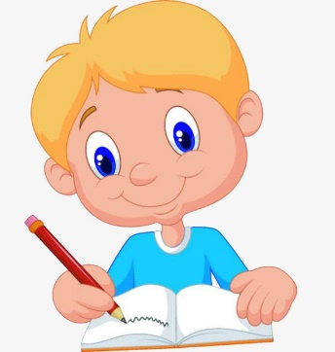
12.She needs ____________________(learn) how to cook healthy food.
13.I suggest ___________________ (drink) lots of water.
14.I forgive you for not __________________(tell) the truth.
15.She is thinking about ____________________(try) a new recipe.

- Phrasal Verbs
Definition | Phrasal Verbs | Phrasal Verbs
A phrasal verb is  a verb that is made up of two or three words and usually has a non-literal meaning. The first word is a verb, and the second word is a particle (either an adverb or a preposition such as in, up, or on). | Here are some phrasal verbs and their definitions which are used for sport:  to warm up: to do movements/stretching to get your muscles/body ready for exercise  to cool down: to do movements/stretching after your main exercise to get it back to normal  to join in: to take part in a sporting event or match  to give up:to surrender/quit  To drop out: to leave a  competition or race | to knock someone out: to beat someone in competition so they are no  longer in it /to hit someone in a boxing match so that they become unconscious  to bulk up: to gain weight and muscle  to work out: to do exercise routines/sessions  to pass out: to lose consciousness  To try out for: to demonstrate your abilities

Complete the sentences with the correct phrasal verb. Circle the correct answer. 10pts
1.The football player (passed out / gave up) due to dehydration.
2.The boxer threw a single punch and immediately (dropped out / knocked out) his opponent.
3.I like to (work out / give up) in the early morning, because that’s when I have the most energy.
4.Let’s (warm up / drop out) with a short run.
5.My daughter is going to (give up / try out for) the school’s most competitive soccer team.
6.He didn’t finish the marathon – he (gave up / cool down) around the 20th mile.
7.Soccer is very physical, injuries are frequent so it’s not uncommon for athletes to (drop out / join in) of competitions.
8.Competitors frequently (cool down / bulk up) before matches.
9.There is a new soccer team, anybody can (join in / warm up).
10.After exercising, I need to (cool down / warm up).

Exercise #2
Name: _____________________________ 50pts, score: __________
I- According to the topics learned answer the following questions.
1. Explain why is important healthy food? 5pts
____________________________________________________________________________________________________________________________________
2. How can you have a healthy diet?5pts
____________________________________________________________________________________________________________________________________
II- Fill in the blanks with the infinitive or gerund.20pts
1) I don't fancy ____________________ (go) out tonight.
2) She avoided ___________________ (tell) him about her plans.
3) I would like ___________________ (come) to the party with you.
4) He enjoys ____________________ (have) a bath in the evening.
5) She kept _____________________ (talk) during the film.
6) I am learning ___________________ (speak) English.
7) Do you mind ___________________ (give) me a hand?
8) She helped me _________________ (carry) my suitcases.
9) I've finished ____________________ (cook) - come and eat!
10) He decided ___________________ (study) biology.

III- Write the correct phrasal Verb according to the meaning.10pts
to warm up to knock someone out to bulk up to give up To try out for

1. ______________________: to demonstrate your abilities.
2. ______________________: to do movements/stretching to get your muscles/body ready for exercise.
3. ____________________: to surrender/quit.
4. ___________________________: to hit someone in a boxing match so that they become unconscious
5. ___________________: to gain weight and muscle
IV- Circle the correct answer.10pts
1. Let’s (warm up / drop out) with a short run.
2. He didn’t finish the marathon – he (gave up / cool down) around the 20th mile.
3. The football player (passed out / gave up) due to dehydration.
4. I like to (work out / give up) in the early morning, because that’s when I have the most energy.
5. There is a new soccer team, anybody can (join in / warm up).

3- Cultural diversity in Panama.
3.1. Reading Comprehension. 10pts
Panama is a huge melting pot of races, but in a very tiny space! Going way back in history, Panama was home to multiple indigenous groups, many of which still live here today. Many scholars believe that the major civilizations of Mesoamerica (Mayans, Aztecs and others) and South America (Incas), used the Isthmus of Panama as trading grounds or at least as a point of transit. The Spanish came and settled down in the first part of the 1500’s, growing the population and added a new race and culture to the mix. They also brought slaves from Africa. Panama in fact was a place of transit as all the goods from the Western part of Central America would cross the isthmus before making their way to Europe. America first transcontinental railroad in the mid 1800’s, the French’s failure to build the Panama Canal in the later part of the 1800’s, and then the USA’s success to build the Panama Canal by 1914 means tens of thousands of labors was brought from literally all over the world. Once the canal was built in the beginning of the 1900’s, immigration boomed as people from all over the world made Panama their new home.

Are you proud of been Panamanian? Write a paragraph about the things that make you feel proud of been Panamanian.
________________________________________________________________________________________________________________________________________________________________________________________________________________________________________________________________________________________________________________________________________________________________________________________________________________________________________________________________________________________________________________________________________________________________________________________________

3.2. Ethnic Groups in Panama
Mention some of the ethnic groups in Panama and illustrate them.15 pts
1.____________________________

2.____________________________

3.____________________________

4.____________________________

5.____________________________

3.3. My Culture and Traditions.
Tell me more about your culture and traditions in your family.12pts
Language my Family and I speak My favorite tradition

My favorite Food Clothes worn in my culture

Holidays celebrated in my culture Other interesting facts

3.4. Grammar
- Tag Questions
A tag question is a special construction in English. It is a statement followed by a mini-question. We use tag questions to ask for confirmation.
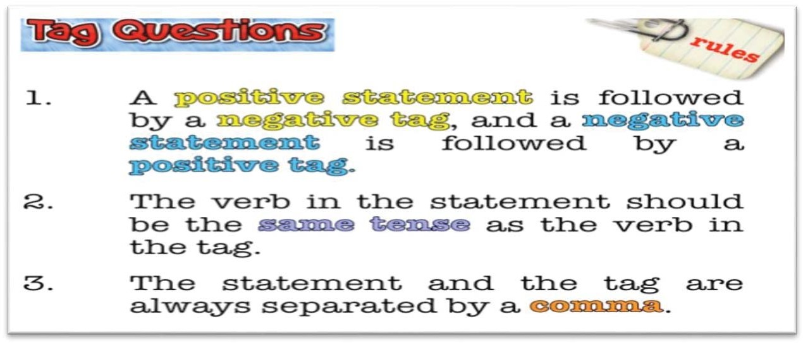
The basic structure of a tag question is:
Positive statement | Negative tag
Snow is white, | isn't it?

negative statement | positive tag
You don't like me, | do you?
Look at these examples with positive statements. You will see that most of the time, the auxiliary verb from the positive statement is repeated in the tag and changed to negative.
(+) positive statement |  |  |  | (-) negative tag
Subject | Auxiliary | Main verb |  | Auxiliary | not | Personal pronouns
She | Is | studying |  | is | n´t | She?
you | are | coming, |  | are | n't | you?
We | have | finished, |  | have | n't | we?
John |  | was | there, | was | n't | he?

Now look at these examples
(-) Negative statemen |  |  |  |  |  | (+) Positive tag
Subject | Auxiliary |  | Main Verb |  |  | Auxiliary | Personal pronoun
It | is | n´t | raining, |  |  | is | It?
You | are | n´t | Coming, |  |  | are | You?

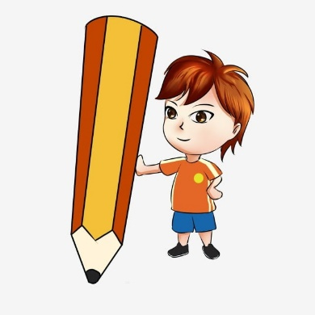
Now is your time to practice.
Put in the correct Tag Question.20pts
1) She's from a small town in China, ____________________?
2) They aren't on their way already, ____________________?
3) We're late again, _________________________?
4) I'm not the person with the tickets, ________________________?
5) Julie isn't an accountant, ___________________________?
6) The weather is really bad today, ________________________?
7) He's very handsome, ___________________________?
8) They aren't in Mumbai at the moment, ___________________________?
9) You aren't from Brazil, ____________________________?
10) John's a very good student, _______________________?
11) I like chocolate very much, ________________________?
12) She doesn't work in a hotel, ________________________?
13) They need some new clothes, ________________________?
14) We live in a tiny flat, ____________________________?
15) She studies very hard every night, ___________________________?
16) David and Julie don't take Chinese classes, _______________________?
17) I often come home late, _________________________?
18) You don't like spicy food, ________________________?
19) She doesn't cook very often, ________________________?
20) We don't watch much TV, ___________________________?

Exercise #3
Name: _____________________________ 50pts, score: __________
I- According to the topics learned answer the following questions.
1. Mention some ethnic groups that lives in our country.12pts
_____________________________ _________________________
_____________________________ _________________________
_____________________________ _________________________
2. Describe your favorite tradition in Panama.6pts
_______________________________________________________________________________________________________________________________________________________________________________________________________________________________________________________________________________________________________________________________________________
3.What is the most important holiday celebrating in your culture?2pts
_______________________________________________________________________
- Write three traditional food in our country.6pts
_________________________, ______________________, ______________________

II- Put in the correct Tag Question.24pts
  - It is raining, _________________?
  - Her eyes are green, __________________?
  - Alan is handsome, ____________________?
  - They live in Lugo, _____________________?
  - We have a fast car,_____________________ ?
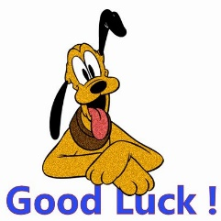
  - He has long hair, _______________________?
  - Ann doesn't like me, ____________________?
  - I am not the best, ______________________?
  - We don't have pens, ____________________?
  - Today isn't Monday, ____________________?
  - Sharks don't talk, _______________________ ?
  - Lucy is never happy,_____________________?
Evaluation
Topics | Points | Grade
1-Avoiding pollution to Conserve our nature.
Date: November 11th,2022
1.2. Vocabulary | 20pts= ______
1.3. Reading Comprehension | 24pts= ______
1.4. Grammar
- Reported Speech | 14pts= ______
- Modals (Should, Shouldn´t / must, mustn´t / have to. | 20pts= ______
Exercise #1 | 35pts= ______
2- The importance of healthy habits for self- caring.
Date: December 2nd ,2022
Reading Comprehension | 24pts= ______
Food Pyramid | 14pts= ______
Grammar
- Gerunds and infinitives | 15pts= ______
- Phrasal Verbs | 10pts= ______
Exercise #2 | 50pts= ______
3- Cultural diversity in Panama.
Date: December 16th, 2022
Reading Comprehension | 10pts= _____
Ethnic Groups in Panama | 15pts= _____
My Culture and Tradition | 12pts= _____
Grammar
- Tag Questions | 20pts= _____
Exercise #3 | 50pts= _____

